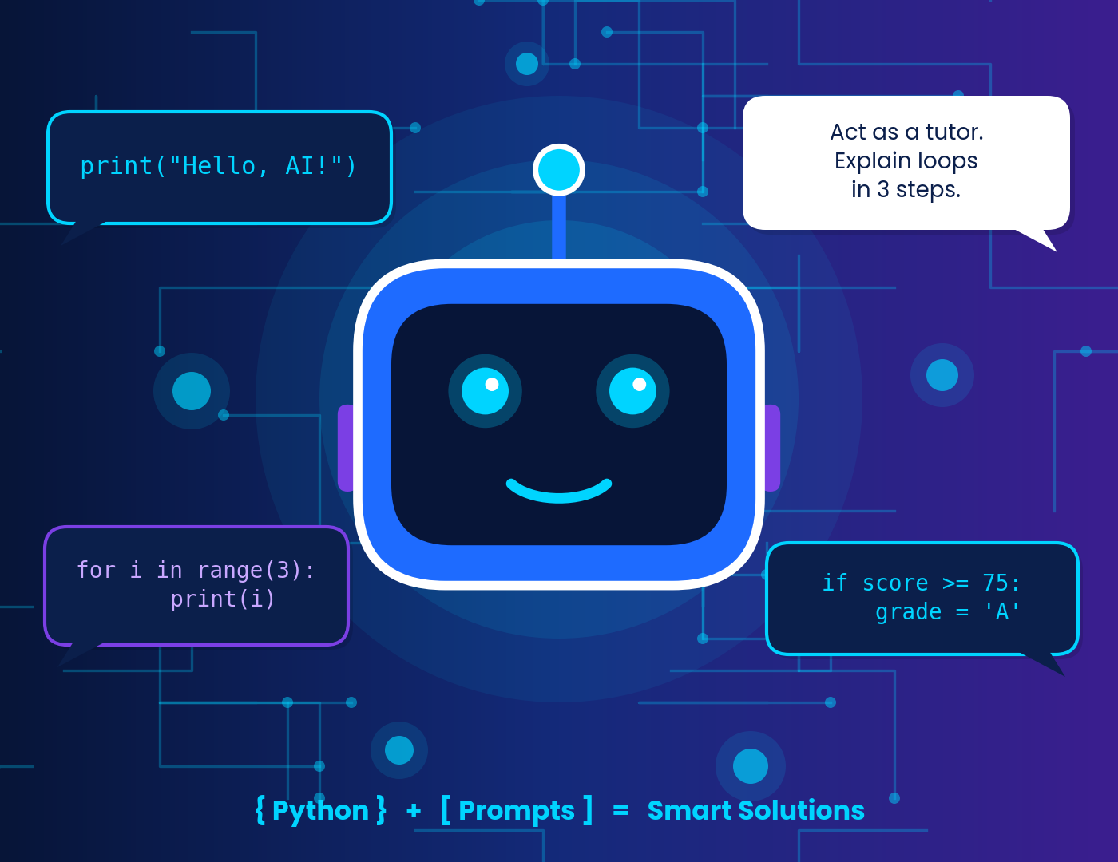
GRADE 11 · AI OLYMPIAD CURRICULUM · MONTH 2 · UNIT 2
Communicate with AI
Python for Smart Solutions
The Art of Prompting
Student Workbook with Teacher Answer Key
Name: ____________________________________ Class / Section: ____________
School: __________________________________ Roll No.: ________________

Contents
PART A · LEARN PYTHON
Chapter 1 · Meet Python: Talking to Computers 4
Chapter 2 · Variables: Labelled Boxes for Data 5
Chapter 3 · Data Types: What Kind of Data Is It? 6
Chapter 4 · Operators: Calculations and Comparisons 8
Chapter 5 · Input & Output: Interactive Programs 10
Chapter 6 · Conditional Statements: Making Decisions 11
Chapter 7 · Loops: Let the Computer Repeat 14
Chapter 8 · Functions: Reusable Mini-Machines 16
Chapter 9 · Simple Python Programs 18
PART B · THE ART OF PROMPTING
Chapter 10 · Prompts: How We Talk to AI 21
Chapter 11 · Prompt Engineering and the TRACE Framework 22
Chapter 12 · Effective Prompting Techniques 24
Chapter 13 · Common Mistakes and Safe, Smart Use 25
Chapter 14 · Python and Prompts Together 26
PART C · PRACTISE, PLAY AND ASSESS
Worksheets 1, 2 and 3 28
Multiple-Choice Questions (30 MCQs) 33
Five Classroom Activities 34
Four Puzzles and Brain Games 36
Quick Quiz 37
Case Studies and Mini-Project 37
Chapter Assessment (30 marks) 41
Summary, Concept Map and Revision Exercises 42
Glossary 44
PART D · TEACHER ANSWER KEY
Teacher Guide and Marking Notes 45
Answer Keys: Worksheets and MCQs 46
Answer Keys: Activities, Puzzles, Case Studies, Project 50
Assessment Answer Key and Marking Scheme 54

Your journey through Unit 2
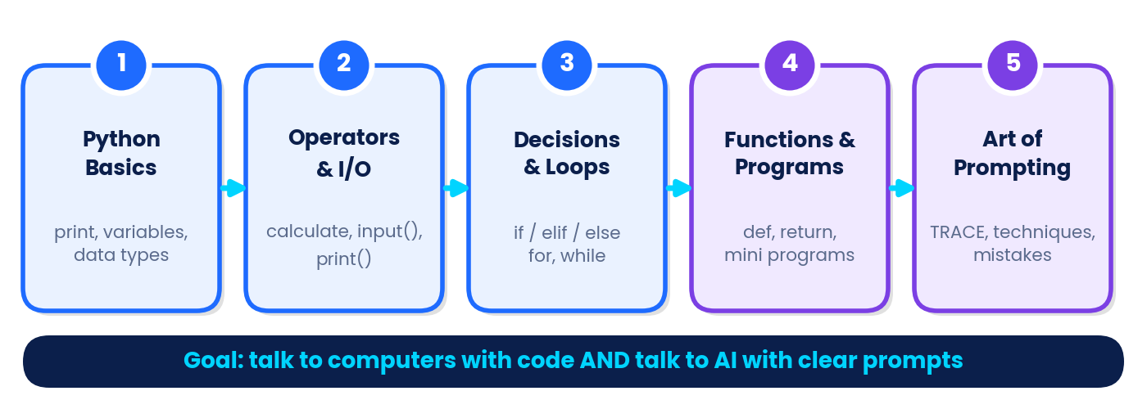
By the end of this unit you will be able to… | How to use this workbook
• write and run simple Python programs  • use variables, data types and operators correctly  • take input and display formatted output  • make decisions with if / elif / else  • repeat tasks with for and while loops  • create and call functions with def and return  • explain what a prompt is and build one with TRACE  • apply prompting techniques and avoid common mistakes  • use AI responsibly: protect privacy and verify facts | Read a chapter and type every program yourself.  Predict the output before you run it.  Look for the mascot's tips and the coloured boxes.  Finish worksheets, MCQs, activities and puzzles in Part C.  Test yourself with the quick quiz and the 30-mark assessment.  Teachers: Part D has full answers, explanations and marking schemes.  All code outputs in this book were generated by actually running the code in Python 3.

 | AI BUDDY SAYS  Hi! I am your AI Buddy. Look for me whenever there is a handy tip, a debugging trick or a prompting secret. Let's go!

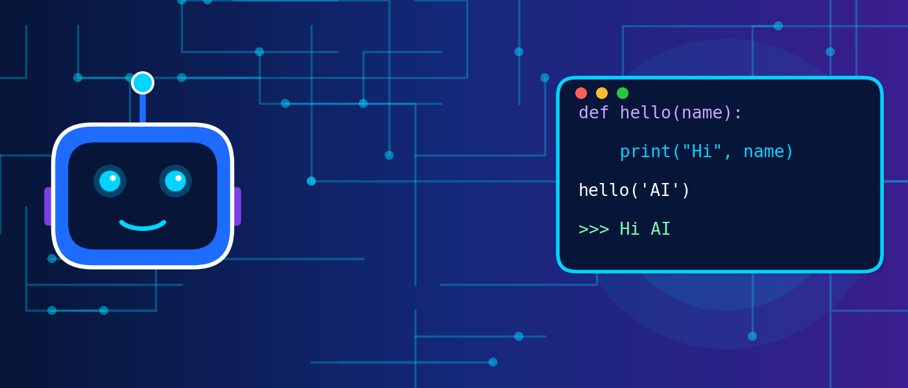
PART A
Learn Python
Python for Smart Solutions · Chapters 1–9

In this part you will… | Self-check: shade a box (1 = not yet, 2 = with help, 3 = confidently)
• write and run simple Python programs  • use variables, data types and operators  • take input and format output  • decide with if / elif / else  • repeat with for and while loops  • build functions with def and return | I can print and comment ○1 ○2 ○3  I can use variables and types ○1 ○2 ○3  I can use operators ○1 ○2 ○3  I can read input() ○1 ○2 ○3  I can write if-elif-else ○1 ○2 ○3  I can write loops ○1 ○2 ○3  I can write a function ○1 ○2 ○3

CHAPTER 1 · PYTHON BASICS
Meet Python: Talking to Computers
KEY IDEA | What you will learn
What a programming language is · why Python is used for AI · how to write and run your first program · comments, indentation · the three kinds of errors and how to debug them.

A computer is extremely fast but has no common sense: it only does exactly what it is told. The instructions we give it are written in a programming language. Python is one of the easiest languages to read, which is why beginners love it, and it is also the most popular language for Artificial Intelligence work such as data analysis, chatbots and machine learning.
REAL-LIFE LINK | Python is everywhere
Music and video apps use Python-powered systems to suggest what you might like next. Scientists use it to study data, and students use it to build games, chatbots and school projects. Fun fact: Python was first released in 1991 and is named after the comedy group Monty Python, not the snake.

How every program works: Input → Process → Output
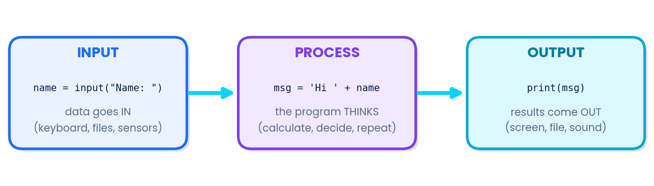
Figure 1.1 – Every Python program follows the same simple pattern.

Where can I run Python?
Tool | What it is | Best for
IDLE / Thonny | Free beginner editors installed with Python | Classroom computers; clear error messages
Online editors / Google Colab | Write and run Python in a web browser, nothing to install | Home practice, sharing notebooks
VS Code | Professional code editor | Bigger projects once you are confident

Your first program
The print() function displays text on the screen. Text must be written inside quotation marks " ".
● Program 1.1 · hello.py
print("Hello, AI World!")  print("I am learning Python.") | OUTPUT  Hello, AI World!  I am learning Python.

A comment starts with #. Python ignores it, but it helps humans understand the code.
● Program 1.2 · comments
# This line is a comment - Python ignores it
print("Comments help humans") # a comment can sit at the end of a line
OUTPUT
Comments help humans

REMEMBER | Three golden rules
Python is case-sensitive: Print and print are different, and only print works.
Indentation matters: lines that belong together are shifted right by 4 spaces (you will see why in Chapter 6).
Every opening bracket or quote needs a closing partner.

When things go wrong: the three kinds of errors
Even professional programmers make mistakes. Finding and fixing them is called debugging. There are three families of bugs:
Error type | When it appears | Example code | What you see (real output)
Syntax error | Before the program runs: the grammar is broken | print("Hello) | SyntaxError: unterminated string literal (detected at line 1)
Runtime error | While running: Python cannot carry out an instruction | print(scor) (typo) | NameError: name 'scor' is not defined
Runtime error | While running: an impossible calculation | print(10 / 0) | ZeroDivisionError: division by zero
Logic error | Program runs but the answer is wrong | average = a + b / 2 with a = 60, b = 80 | Prints 100.0 – but the true average is 70.0
Error wording may differ slightly between Python versions; newer versions may add a hint such as "Did you mean…?".
AI BUDDY SAYS
Debug like a detective: 1) read the last line of the error message; 2) look at the line number it mentions; 3) check spelling, colons, quotes and brackets; 4) add print() lines to see what values your variables hold.

TRY IT YOURSELF
Try it: Type Program 1.1 and change the messages to introduce yourself. Then delete one closing quote on purpose and read the error message.

CHAPTER 2 · VARIABLES
Variables: Labelled Boxes for Data
KEY IDEA | What you will learn
What a variable is · how to create and change one · rules for good names · assigning several variables at once · swapping values.

A variable is a named place in the computer's memory where a value is stored. Think of a school locker: the locker has a label (the name), and you can keep something inside (the value). Later you can open it, look inside, or replace the contents.
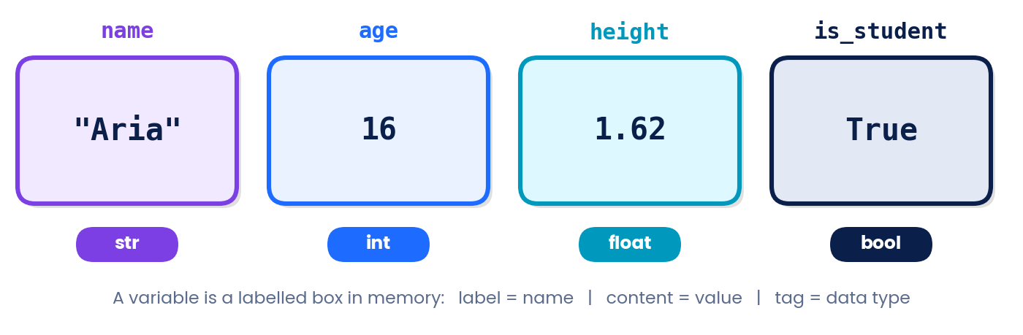
Figure 2.1 – A variable has a name (label), a value (content) and a data type (kind of data).
You create a variable with the assignment operator =. It means "store the value on the right into the name on the left" – it does not mean "is equal to" as in maths.
● Program 2.1 · creating variables
name = "Aria"  age = 16  height = 1.62  is_student = True  print(name, age, height, is_student) | OUTPUT  Aria 16 1.62 True

Changing a variable
A variable can be updated at any time. The right side is calculated first, then stored.
● Program 2.2 · updating a variable
score = 10  print(score)  score = score + 5  print(score) | OUTPUT  10  15

Rules for naming variables
Rule | Good example | Not allowed
Use letters, digits and underscores only | total_marks, score2 | total-marks, my score, price$
Cannot start with a digit | item1 | 1item
Cannot be a Python keyword | class_name | class, for, if, True
Case-sensitive | Score and score are two variables | —
Make names meaningful | average_marks | x1, abc (legal but unclear)

Several variables at once, and swapping
Python lets you assign many variables in one line. You can even swap two values without a temporary variable.
● Program 2.3 · multiple assignment
x = y = z = 0  p, q = 3, 4  print(x, y, z, p, q) | OUTPUT  0 0 0 3 4

● Program 2.4 · swapping two values
a = 5  b = 9  a, b = b, a  print("a =", a, " b =", b) | OUTPUT  a = 9 b = 5

WATCH OUT | Common mistake
5 = score is wrong. The name goes on the left, the value on the right. Also remember: score = 10 stores 10; to compare, Python uses == (see Chapter 4).

TRY IT YOURSELF
Try it: Create variables city, temperature and is_sunny, print them, then change temperature by adding 2 and print again.

CHAPTER 3 · DATA TYPES
Data Types: What Kind of Data Is It?
KEY IDEA | What you will learn
The four basic types int, float, str, bool · using type() · working with text · converting between types · a preview of lists.

Data comes in different kinds, and Python must know the kind to decide what operations are allowed. You can add two numbers, but adding a number to a word makes no sense. These kinds are called data types.
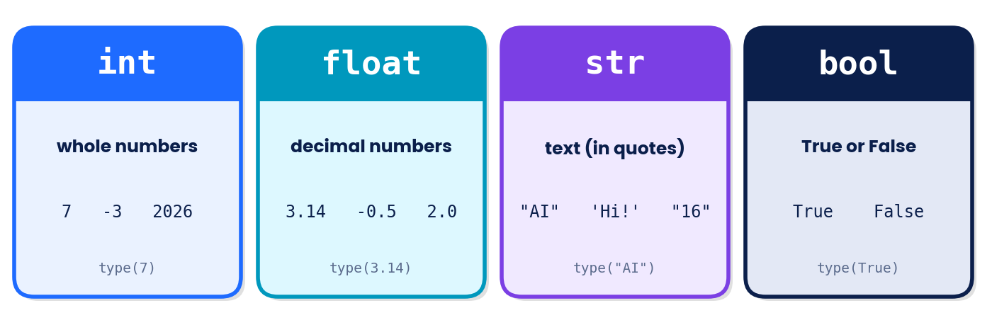
Figure 3.1 – The four basic data types.
Type | Stores | Real-life example | Python example
int | Whole numbers | Students in a class, jersey number | age = 16
float | Numbers with decimals | Height, temperature, price | height = 1.62
str | Text (inside quotes) | Name, city, message | name = "Aria"
bool | True or False only | Is the light on? Has the user logged in? | is_on = True

Use type() to ask Python what type a value has:
● Program 3.1 · checking types
print(type(42))  print(type(3.14))  print(type("AI"))  print(type(True)) | OUTPUT  <class 'int'>  <class 'float'>  <class 'str'>  <class 'bool'>

Working with strings
A string is a sequence of characters. Each character has a position called an index, and counting starts from 0.
Character | A | r | t | i | f | i | c | i | a | l
Index | 0 | 1 | 2 | 3 | 4 | 5 | 6 | 7 | 8 | 9

● Program 3.2 · string tools
word = "Artificial"  print(len(word))  print(word.upper())  print(word.lower())  print(word[0])  print(word + " Intelligence")  print("Ha" * 3) | OUTPUT  10  ARTIFICIAL  artificial  A  Artificial Intelligence  HaHaHa

Converting between types
Functions int(), float() and str() convert one type into another; bool() tells you whether a value counts as True or False. Zero, an empty string "" and empty containers count as False; everything else counts as True.
● Program 3.3 · type conversion
age_text = "16"  age_num = int(age_text)  print(age_num + 1)  print(float(7))  print(str(25) + " years")  print(int(9.99))  print(bool(0), bool("hi"), bool("")) | OUTPUT  17  7.0  25 years  9  False True False

WATCH OUT | Watch out
int(9.99) gives 9, not 10: it chops off the decimal part, it does not round. And int("hello") causes an error because the text is not a number.

Bonus preview: lists
A list stores many values in one variable, written in square brackets. You will use lists in loops.
● Program 3.4 · a first list
subjects = ["Maths", "AI", "Physics"]
print(subjects[1])
subjects.append("English")
print(len(subjects))
print(subjects)
OUTPUT
AI
4
['Maths', 'AI', 'Physics', 'English']

TRY IT YOURSELF
Try it: Predict, then check by running: print(type("10")), print(type(10 / 5)), print("10" * 2).

CHAPTER 4 · OPERATORS
Operators: Doing Calculations and Comparisons
KEY IDEA | What you will learn
Arithmetic, comparison, logical and assignment operators · operator priority (precedence) · evaluating expressions step by step.

An operator is a symbol that tells Python to perform an action on operands (the values around it). In 17 + 5, + is the operator and 17 and 5 are operands.

1. Arithmetic operators
Operator | Meaning | Example (a = 17, b = 5) | Result
+ | Addition | a + b | 22
- | Subtraction | a - b | 12
* | Multiplication | a * b | 85
/ | Division (always float) | a / b | 3.4
// | Floor division (whole part) | a // b | 3
% | Modulus (remainder) | a % b | 2
** | Power (exponent) | a ** 2 | 289

● Program 4.1 · arithmetic (outputs match the table)
a = 17  b = 5  print(a + b)  print(a - b)  print(a * b)  print(a / b)  print(a // b)  print(a % b)  print(a ** 2) | OUTPUT  22  12  85  3.4  3  2  289

REAL-LIFE LINK | Where is % used?
Remainders power real tools: number % 2 == 0 tells you if a number is even; hours % 12 converts 24-hour time to clock time (14 % 12 = 2, so 14:00 is 2 o'clock); and // tells you how many full boxes you can pack.

2. Comparison operators
These compare two values and always give a bool (True or False): == equal to, != not equal to, > greater than, < less than, >= greater than or equal to, <= less than or equal to.
● Program 4.2 · comparisons
marks = 72  print(marks > 50)  print(marks == 72)  print(marks != 100)  print(marks <= 70) | OUTPUT  True  True  True  False

3. Logical operators
Operator | Meaning | Real-life sentence
and | True only if both sides are True | You can enter if you have a ticket and your ID.
or | True if at least one side is True | Free entry if you are under 5 or over 65.
not | Reverses True/False | Not raining → go out.

● Program 4.3 · logical operators
age = 16  has_id = True  print(age >= 16 and has_id)  print(age < 13 or age > 19)  print(not has_id) | OUTPUT  True  False  False

4. Assignment operators
Shortcuts that update a variable: +=, -=, *=, /=. For example points += 5 means points = points + 5.
● Program 4.4 · shortcuts (10 → 15 → 12 → 24)
points = 10  points += 5  points -= 3  points *= 2  print(points) | OUTPUT  24

Operator priority (precedence)
When an expression has several operators, Python follows an order, just like BODMAS in maths. Use brackets to take control.
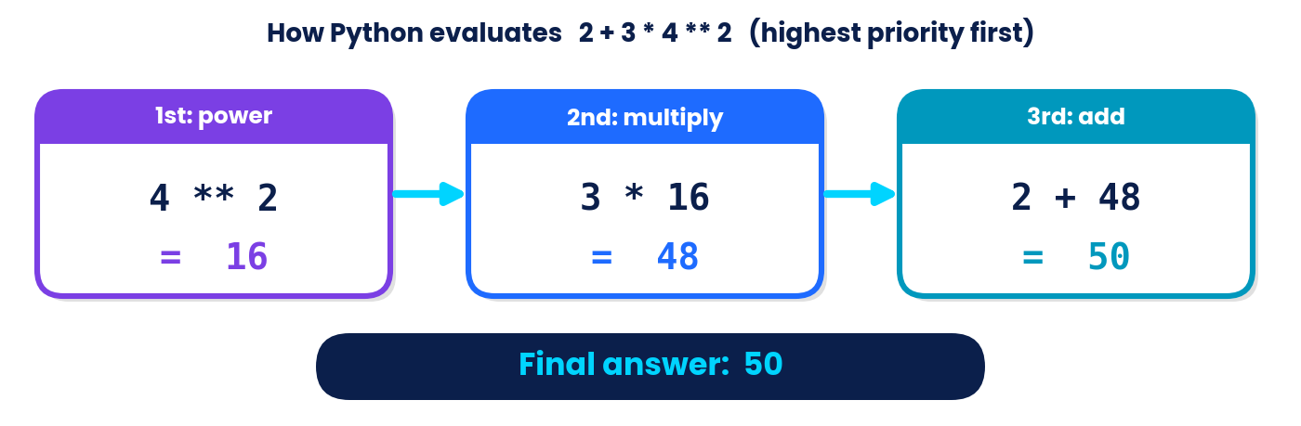
Priority | Operators
1 (highest) | ( ) brackets
2 | ** power
3 | * / // % (left to right)
4 | + - (left to right)
5 | comparisons == != > < >= <=
6 | not, then and, then or (lowest)

● Program 4.5 · precedence in action
print(2 + 3 * 4)  print((2 + 3) * 4)  print(2 + 3 * 4 ** 2)  print(20 / 4 * 2) | OUTPUT  14  20  50  10.0

TRY IT YOURSELF
Try it: Work out by hand, then verify: print(7 + 3 * 2), print((7 + 3) * 2), print(15 % 4), print(2 ** 5).

CHAPTER 5 · INPUT AND OUTPUT
Input & Output: Making Programs Interactive
KEY IDEA | What you will learn
Customising print() with sep and end · f-strings · reading user input with input() · converting input to numbers · a complete billing program.

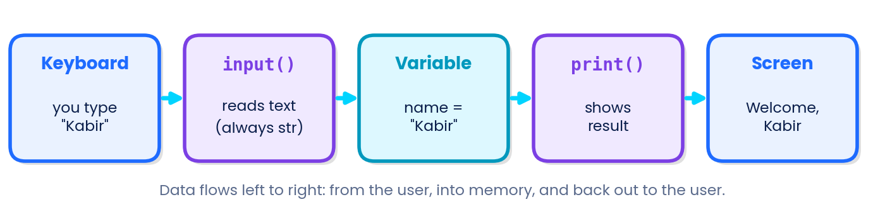
Figure 5.1 – How data moves through a simple interactive program.

Output with print()
print() can show several items at once. By default it puts a space between them (sep) and ends with a new line (end). You can change both.
● Program 5.1 · sep and end
print("Hello", "AI", "learners")  print("2026", "10", "11", sep="-")  print("Loading", end="...")  print("done") | OUTPUT  Hello AI learners  2026-10-11  Loading...done

f-strings: put variables inside text
Put the letter f before the opening quote, then write variables or calculations inside curly brackets { }. Add :.2f to show exactly 2 decimal places (useful for money).
● Program 5.2 · f-strings
name = "Riya"  marks = 87.5  print(f"{name} scored {marks} marks.")  print(f"Next year she will be {16 + 1}.") | OUTPUT  Riya scored 87.5 marks.  Next year she will be 17.

Input with input()
input("message") shows the message, waits for the user to type, and gives back what was typed as text (str). Store it in a variable.
● Program 5.3 · asking for a name
name = input("Enter your name: ")  print("Welcome,", name) | OUTPUT  Enter your name: Kabir  Welcome, Kabir

WATCH OUT | Big beginner trap
input() always returns text, even if the user types a number. To calculate, convert with int() or float().

See the difference. Without conversion, + joins text; with conversion, it adds numbers:
● Program 5.4a · no conversion (joins text!)
a = input("First number: ")  b = input("Second number: ")  print(a + b) | OUTPUT  First number: 12  Second number: 8  128

● Program 5.4b · with int() (adds numbers)
a = int(input("First number: "))  b = int(input("Second number: "))  print(a + b) | OUTPUT  First number: 12  Second number: 8  20

● Program 5.5 · area of a square
side = float(input("Side of square (cm): "))  area = side * side  print("Area =", area, "sq cm") | OUTPUT  Side of square (cm): 4.5  Area = 20.25 sq cm

Mini billing program
● Program 5.6 · shop bill
item = input("Item: ")  price = float(input("Price per item (Rs): "))  qty = int(input("Quantity: "))  total = price * qty  print(f"{qty} x {item} = Rs {total:.2f}") | OUTPUT  Item: Notebook  Price per item (Rs): 45.5  Quantity: 3  3 x Notebook = Rs 136.50

AI BUDDY SAYS
In the input boxes above, the typed answers (Kabir, 12, 8, 4.5 …) are shown after the colon. In a real run you type them and press Enter.

TRY IT YOURSELF
Try it: Write a program that asks for a name and the number of hours studied today, then prints a friendly message such as "Riya studied 2.5 hours today."

CHAPTER 6 · CONDITIONAL STATEMENTS
Conditional Statements: Making Decisions
KEY IDEA | What you will learn
if, if-else, elif ladders and nested if · how indentation controls what runs · reading decision flowcharts.

Every day you make decisions: if it rains, take an umbrella; else wear a cap. Programs make decisions the same way using conditions – expressions that are either True or False.
REAL-LIFE LINK | Decisions inside apps
A fitness band that buzzes if your heart rate is too high, a game that says "Level up!" if your score passes 100, and a ticket website that shows a student discount if your age is below 18 all use conditional statements.

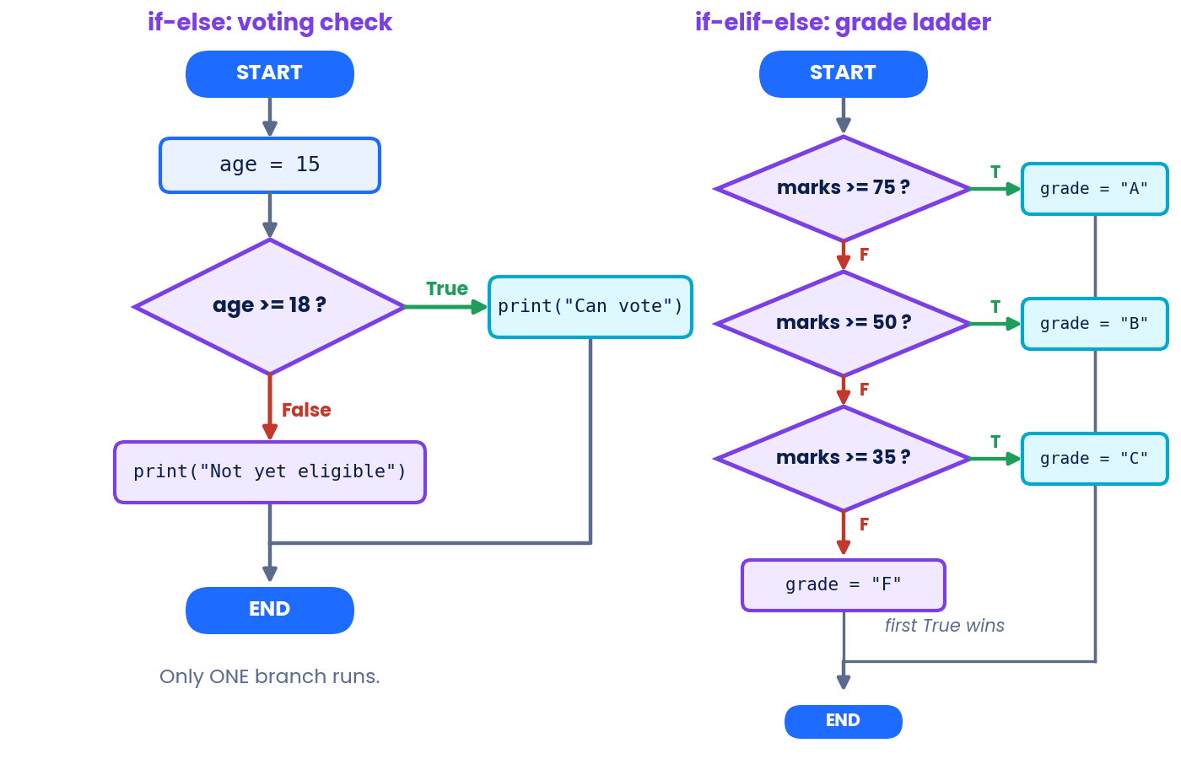
Figure 6.1 – Flowcharts: the diamond asks a True/False question; only one branch runs.

The if statement
The indented block runs only if the condition is True. Do not forget the colon : and the 4-space indentation.
● Program 6.1 · if
temperature = 38  if temperature > 37:  print("You may have a fever.")  print("Stay hydrated!") | OUTPUT  You may have a fever.  Stay hydrated!

if – else
● Program 6.2 · if-else
age = 15  if age >= 18:  print("Eligible to vote")  else:  print("Not eligible yet") | OUTPUT  Not eligible yet

if – elif – else
Use elif (short for "else if") for more than two choices. Python checks from the top and runs the first True branch only.
● Program 6.3 · grade ladder
marks = 78  if marks >= 90:  grade = "A+"  elif marks >= 75:  grade = "A"  elif marks >= 60:  grade = "B"  elif marks >= 40:  grade = "C"  else:  grade = "Needs improvement"  print("Grade:", grade) | OUTPUT  Grade: A

WATCH OUT | Order matters!
In Program 6.3 the highest limit is tested first. If you tested marks >= 40 first, 78 marks would be given the lowest passing grade, because the first True branch wins.

Nested conditions and logical operators
An if can sit inside another if (nested). You can also combine conditions with and, or, not.
● Program 6.4 · nested if
has_ticket = True  age = 12  if has_ticket:  if age < 5:  print("Free entry")  else:  print("Entry allowed")  else:  print("Please buy a ticket") | OUTPUT  Entry allowed

● Program 6.5 · combining conditions
is_raining = True  has_umbrella = False  if is_raining and not has_umbrella:  print("Wait inside")  else:  print("Go out") | OUTPUT  Wait inside

Classic use: even or odd
● Program 6.6 · % with if
num = 27  if num % 2 == 0:  print(num, "is even")  else:  print(num, "is odd") | OUTPUT  27 is odd

Common error | Wrong | Right
Using = instead of == | if age = 18: | if age == 18:
Missing colon | if age >= 18 | if age >= 18:
Body not indented | if x > 5: then print("big") at the left edge | Indent the body by 4 spaces

TRY IT YOURSELF
Try it: Write a program that stores a temperature and prints "Cold" if below 15, "Pleasant" if 15 to 30, and "Hot" if above 30.

CHAPTER 7 · LOOPS
Loops: Let the Computer Repeat
KEY IDEA | What you will learn
Why loops save effort · for loops and range() · while loops · break and continue · tracing a loop with a table.

Imagine writing print("Well done!") 100 times. A loop repeats instructions automatically. Real-life loops: a playlist on repeat, a teacher calling every name in the attendance register, or a washing machine repeating its spin cycle.

The for loop and range()
Use for when you know how many times to repeat or you want to visit each item of a list. range(5) gives the numbers 0, 1, 2, 3, 4.
● Program 7.1 · a basic for loop
for i in range(5):  print("Step", i) | OUTPUT  Step 0  Step 1  Step 2  Step 3  Step 4

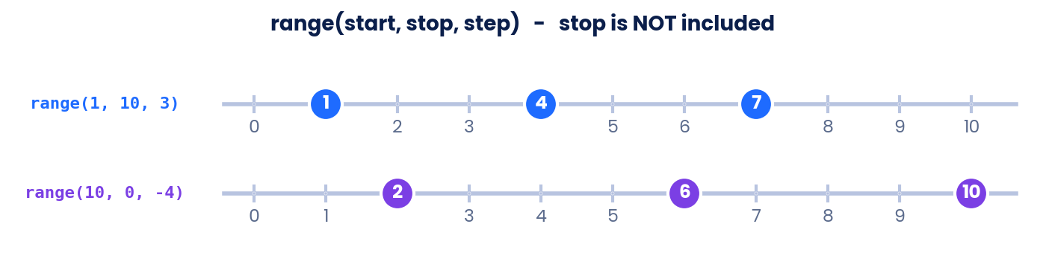
Figure 7.1 – range(start, stop, step): the loop stops just before the stop value.
● Program 7.2 · range() forms
print(list(range(1, 6)))  print(list(range(2, 11, 2)))  print(list(range(5, 0, -1))) | OUTPUT  [1, 2, 3, 4, 5]  [2, 4, 6, 8, 10]  [5, 4, 3, 2, 1]

● Program 7.3 · looping through a list
tools = ["Python", "Chatbot", "Notebook"]  for t in tools:  print("I use", t) | OUTPUT  I use Python  I use Chatbot  I use Notebook

Accumulating a total
● Program 7.4 · sum of 1 to 5
total = 0  for n in range(1, 6):  total = total + n  print("Sum =", total) | OUTPUT  Sum = 15

A trace table follows the variables step by step. This is how you "run the code in your head":
Round | n | total = total + n
start | – | 0
1 | 1 | 1
2 | 2 | 3
3 | 3 | 6
4 | 4 | 10
5 | 5 | 15

The while loop
while repeats as long as a condition stays True. Use it when you do not know how many repeats are needed, such as "keep asking until the password is right".
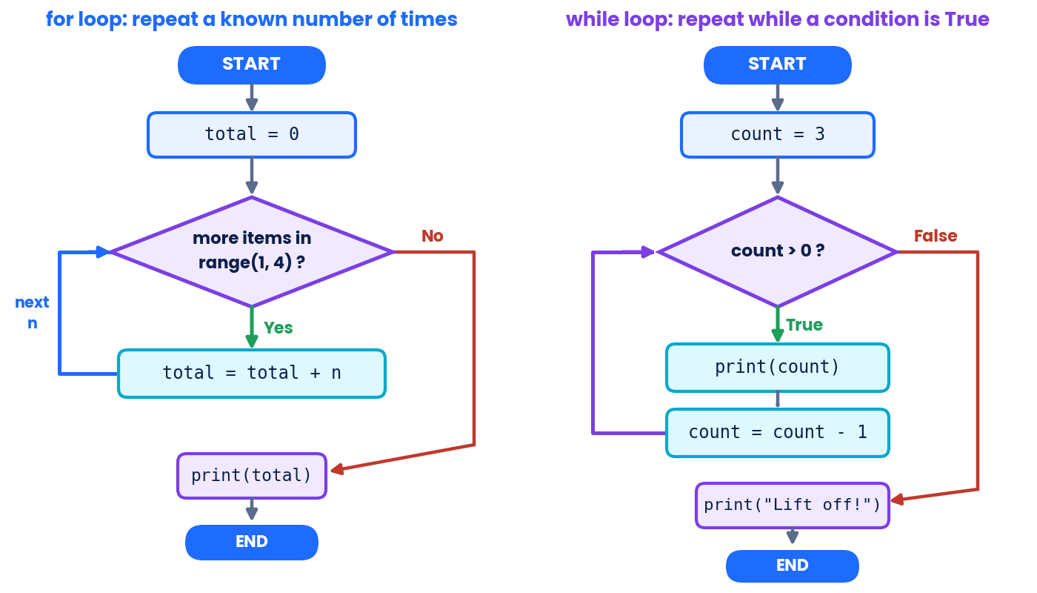
Figure 7.2 – Both loops test a condition, run the body, and come back to test again.
● Program 7.5 · countdown
count = 3  while count > 0:  print(count)  count = count - 1  print("Lift off!") | OUTPUT  3  2  1  Lift off!

● Program 7.6 · password attempts (max 3 tries)
password = "ai123"  attempt = ""  tries = 0  while attempt != password and tries < 3:  attempt = input("Password: ")  tries += 1  if attempt == password:  print("Access granted")  else:  print("Locked") | OUTPUT  Password: abc  Password: ai123  Access granted

WATCH OUT | Infinite loops
If the condition never becomes False (for example you forget count = count - 1), the loop runs forever. Stop a runaway program with Ctrl + C (or the Stop button).

break and continue
break exits the loop at once. continue skips the rest of the current round and moves to the next.
● Program 7.7 · skip 3, stop at 6
for n in range(1, 8):  if n == 3:  continue  if n == 6:  break  print(n) | OUTPUT  1  2  4  5

Patterns and tables
● Program 7.8 · star triangle
for row in range(1, 5):  print("*" * row) | OUTPUT  *  **  ***  ****

● Program 7.9 · multiplication table of 7
for i in range(1, 6):  print(7, "x", i, "=", 7 * i) | OUTPUT  7 x 1 = 7  7 x 2 = 14  7 x 3 = 21  7 x 4 = 28  7 x 5 = 35

To use the position of items in a list, combine range() with len():
● Program 7.10 · index and item
names = ["Asha", "Ben", "Chitra"]  for i in range(len(names)):  print(i, names[i]) | OUTPUT  0 Asha  1 Ben  2 Chitra

TRY IT YOURSELF
Try it: Write a loop that prints the squares of the numbers 1 to 5, and a while loop that prints 10, 8, 6, 4, 2.

CHAPTER 8 · FUNCTIONS
Functions: Reusable Mini-Machines
KEY IDEA | What you will learn
Why we use functions · def, parameters, arguments and return · default values · local variables · print vs return.

A function is a named block of code that does one job and can be used again and again. A vending machine is a good picture: you put in a coin and a choice (input), it works inside (process), and delivers a snack (output). You have already used built-in functions such as print(), input(), len() and type(). Now you will build your own with def.
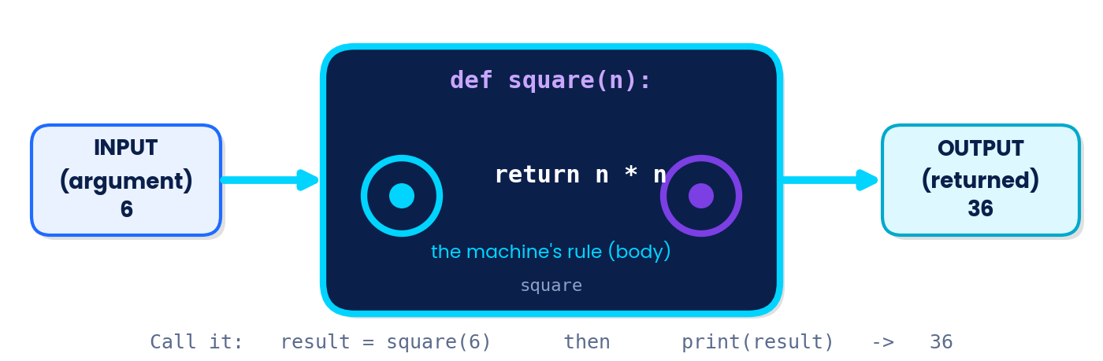
Figure 8.1 – A function takes inputs, follows its rule, and returns an output.
Term | Meaning | In def square(n):
def | Keyword that starts a function definition | def
Parameter | Placeholder name inside the brackets | n
Argument | The real value passed when you call the function | 6 in square(6)
return | Sends a result back to the caller | return n * n

● Program 8.1 · a function that prints
def greet(name):  print("Hello,", name)  greet("Meera")  greet("Arjun") | OUTPUT  Hello, Meera  Hello, Arjun

● Program 8.2 · a function that returns
def square(n):  return n * n  result = square(6)  print(result)  print(square(4) + square(3)) | OUTPUT  36  25

Default values and decisions inside functions
● Program 8.3 · default parameter
def area_rect(length, width=1):  return length * width  print(area_rect(5, 3))  print(area_rect(5)) | OUTPUT  15  5

● Program 8.4 · grade_of() uses if-elif
def grade_of(marks):  if marks >= 75:  return "Distinction"  elif marks >= 40:  return "Pass"  return "Fail"  print(grade_of(82))  print(grade_of(55))  print(grade_of(30)) | OUTPUT  Distinction  Pass  Fail

● Program 8.5 · Celsius to Fahrenheit
def to_fahrenheit(c):  return c * 9 / 5 + 32  print(to_fahrenheit(0))  print(to_fahrenheit(100))  print(to_fahrenheit(40)) | OUTPUT  32.0  212.0  104.0

Scope: variables live inside their function
A variable created inside a function is local: it exists only while the function runs. Using it outside gives an error.
● Program 8.6 · local variable
def add_bonus(score):
bonus = 5
return score + bonus

print(add_bonus(20))
print(bonus)
OUTPUT
25
NameError: name 'bonus' is not defined

 | print() inside a function | return
What it does | Shows a value on the screen | Hands a value back to the caller
Can you store the result? | No | Yes: x = square(4)
Use it when… | You only want to display something | You want to reuse the result in later steps

TRY IT YOURSELF
Try it: Write def average(a, b) that returns the average of two numbers. Print average(70, 80).

CHAPTER 9 · SIMPLE PYTHON PROGRAMS
Putting It All Together: Five Smart Programs
KEY IDEA | Problem-solving recipe
1 Understand the problem → 2 Plan (steps or flowchart) → 3 Code a small part → 4 Test with easy numbers → 5 Improve. Always test with values whose answers you can work out yourself.

Program A · Odd or even checker (loops + if)
● Program 9.1
for n in range(1, 11):  if n % 2 == 0:  print(n, "even")  else:  print(n, "odd") | OUTPUT  1 odd  2 even  3 odd  4 even  5 odd  6 even  7 odd  8 even  9 odd  10 even

Program B · Marks calculator (list + loop + if)
The loop adds every mark to total; dividing by len(marks) gives the average.
● Program 9.2
marks = [78, 85, 92, 66, 74]  total = 0  for m in marks:  total += m  average = total / len(marks)  print("Total:", total)  print("Average:", average)  if average >= 75:  print("Great work!")  else:  print("Keep practising!") | OUTPUT  Total: 395  Average: 79.0  Great work!

Program C · A rule-based chatbot (function + if-elif)
The function turns the message into lower case and looks for keywords. This is the simplest kind of "conversation with a computer"; modern AI chatbots work very differently, but this program shows how a machine can respond to words.
● Program 9.3
def reply(message):
message = message.lower()
if "hello" in message or "hi " in message:
return "Hello! How can I help you?"
elif "homework" in message:
return "Tell me the subject and I will guide you."
elif "bye" in message:
return "Goodbye! Keep learning."
else:
return "Sorry, I did not understand."

for text in ["Hello there", "Need help with homework", "Bye", "What is 2+2?"]:
print("You:", text)
print("Bot:", reply(text))
OUTPUT
You: Hello there
Bot: Hello! How can I help you?
You: Need help with homework
Bot: Tell me the subject and I will guide you.
You: Bye
Bot: Goodbye! Keep learning.
You: What is 2+2?
Bot: Sorry, I did not understand.

Program D · Password strength checker (function + loop + if)
● Program 9.4
def strength(password):
score = 0
if len(password) >= 8:
score += 1
has_digit = False
for ch in password:
if ch.isdigit():
has_digit = True
if has_digit:
score += 1
if score == 2:
return "Strong"
elif score == 1:
return "Medium"
return "Weak"

for p in ["cat", "mango99", "sunshine", "robot2026"]:
print(p, "->", strength(p))
OUTPUT
cat -> Weak
mango99 -> Medium
sunshine -> Medium
robot2026 -> Strong

Program E · Number guessing game (loop + if-elif + break)
● Program 9.5
secret = 7  guesses = [3, 9, 7]  for g in guesses:  if g < secret:  print(g, "is too low")  elif g > secret:  print(g, "is too high")  else:  print(g, "is correct! You win!")  break | OUTPUT  3 is too low  9 is too high  7 is correct! You win!

REAL-LIFE LINK | From programs to AI projects
Larger AI tools are built from exactly these ingredients: variables to hold data, conditions to decide, loops to process thousands of items, and functions to organise the work.

TRY IT YOURSELF
Try it: Change Program 9.3 so that it also answers "thanks" with "You are welcome!" and test it with the message "Thanks a lot".

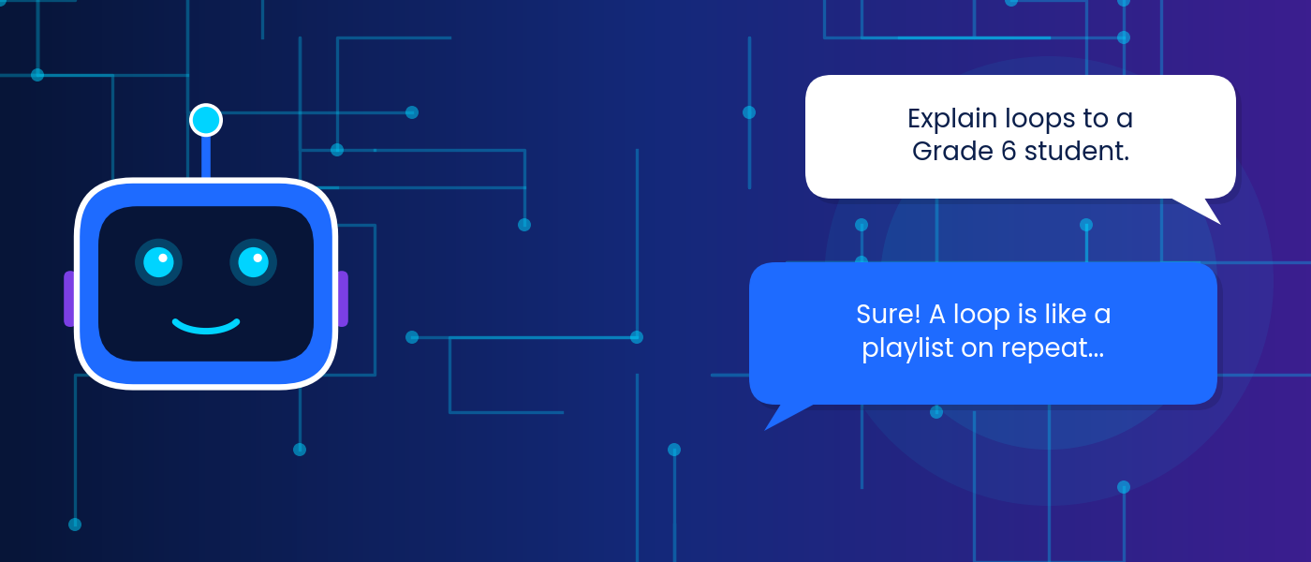
PART B
The Art of Prompting
Communicating with AI · Chapters 10–14

In this part you will… | Self-check: shade a box (1 = not yet, 2 = with help, 3 = confidently)
• explain what a prompt is  • build prompts with the TRACE framework  • apply seven prompting techniques  • spot and fix common mistakes  • use AI safely, honestly and with checking  • combine Python and prompts | I can define a prompt ○1 ○2 ○3  I can use TRACE ○1 ○2 ○3  I can use few-shot and role prompts ○1 ○2 ○3  I can refine a prompt ○1 ○2 ○3  I can name prompt mistakes ○1 ○2 ○3  I can verify AI answers ○1 ○2 ○3

CHAPTER 10 · TALKING TO AI
Prompts: How We Talk to AI
KEY IDEA | What you will learn
What a prompt is · the human–AI conversation loop · why the same AI gives different answers to different prompts · what a good prompt does.

With Python you give a computer exact instructions in a strict language. With an AI chatbot you give instructions in everyday language. What you type is called a prompt: the question, instruction or information you give an AI to get a response. The AI's reply is the response (or output).
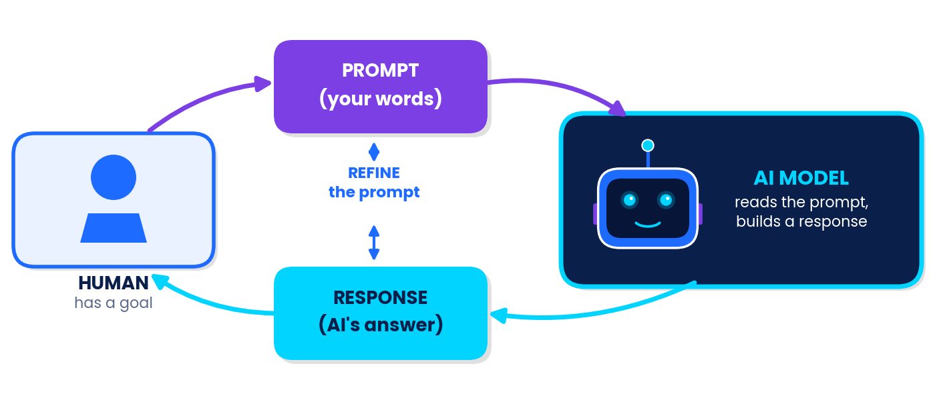
Figure 10.1 – Communicating with AI is a loop: prompt → response → refine → prompt…

Python vs prompts: two ways to give instructions
 | Python program | AI prompt
Language | Strict syntax: one wrong colon breaks it | Natural language: flexible, but can be misunderstood
Result | Same input always gives the same output | Answers can vary from one try to the next
Who must be precise? | You, about the syntax | You, about the meaning: task, audience, format
Checking | Run it and read errors | Read the answer critically and verify facts

Why do prompts matter?
An AI system does not read your mind. It only has the words you provide. It uses them to work out the most helpful-looking response, a bit like a very well-read assistant who has never met you. If the words are vague, it must guess what you want.
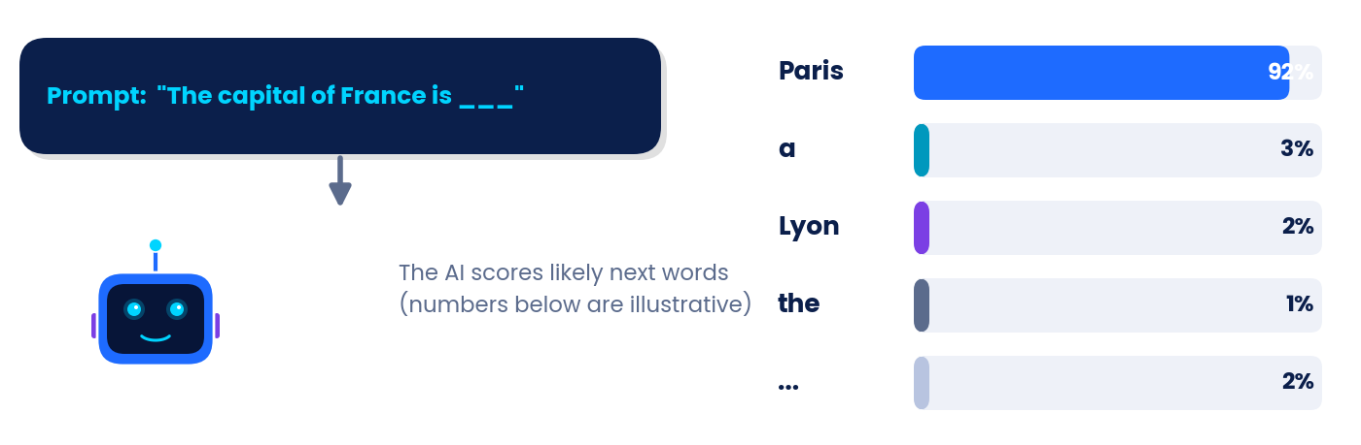
Figure 10.2 – Simplified idea: given the words so far, the AI weighs likely continuations. The percentages are illustrative, not real measurements.
REAL-LIFE LINK | The same question, two prompts
Prompt 1: "Tell me about bats." → Could be animals… or cricket bats!
Prompt 2: "Explain how bats find food in the dark, for a Grade 8 student, in 4 bullet points." → Clear, targeted, easy to check.

AI BUDDY SAYS
A prompt is not a magic spell. It is a brief for a helper: say what you need, for whom, and how you want it delivered.

TRY IT YOURSELF
Think & tell: Write one vague prompt and one improved prompt for "help with my science project". Say what extra details the second one contains.

CHAPTER 11 · PROMPT ENGINEERING
Prompt Engineering and the TRACE Framework
KEY IDEA | What you will learn
What prompt engineering means · the five building blocks of a strong prompt (TRACE) · how to climb from a weak to a strong prompt.

Prompt engineering is the skill of designing and improving prompts so that an AI gives useful, accurate and well-organised results. It is part writing, part logic, and part testing. Just as a programmer plans a program, a good prompter plans a prompt.

The TRACE framework
To remember what a strong prompt contains, use TRACE. You do not need all five parts every time, but the more you include, the less the AI has to guess.
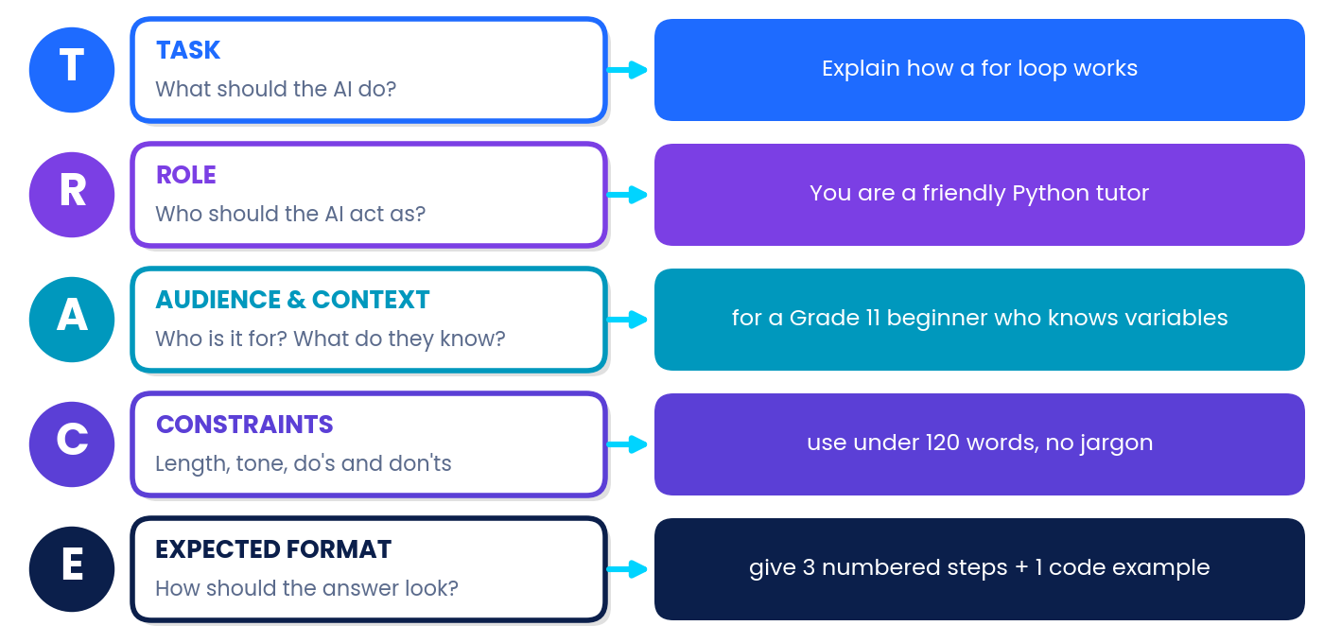
Figure 11.1 – TRACE: Task, Role, Audience & context, Constraints, Expected format.
Part | Question it answers | Starter phrases
Task | What must the AI do? | "Explain…", "Summarise…", "Give me 5 ideas for…", "Check this code…"
Role | Who should the AI act as? | "You are a patient maths tutor…", "Act as a quiz master…"
Audience & context | Who is it for? What background is needed? | "…for a Grade 9 student who knows variables but not loops."
Constraints | What limits apply? | "Under 100 words", "simple words", "no jargon", "use a cricket analogy"
Expected format | How should the answer look? | "as a table", "3 numbered steps", "bullet points", "end with 2 quiz questions"

From weak to strong: the prompt ladder
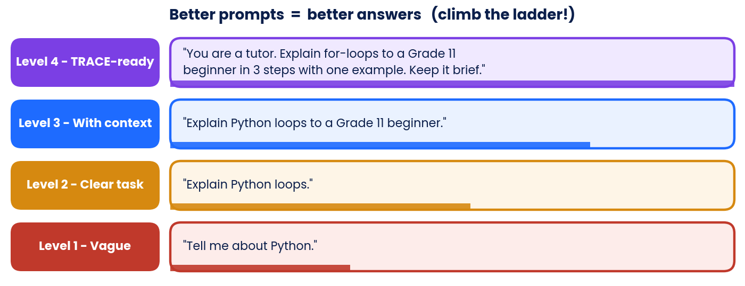
Figure 11.2 – Each rung adds information the AI would otherwise have to guess.
REAL-LIFE LINK | A prompt built with TRACE
[Role] You are a friendly Python tutor. [Task] Explain what a for loop is [Audience] to a Grade 11 student who knows variables and print(). [Constraints] Use a school-bell analogy and keep it under 100 words. [Format] Finish with one 3-line code example.

WATCH OUT | More is not always better
Adding useless detail or contradictory rules makes a prompt confusing. Aim for clear, relevant and complete, not just long.

TRY IT YOURSELF
Try it: Label the TRACE parts in: "Act as a career counsellor. Suggest three careers in AI for a Grade 11 student who likes maths. Keep each to one line and show them as a table."

CHAPTER 12 · EFFECTIVE PROMPTING TECHNIQUES
Effective Prompting Techniques
KEY IDEA | What you will learn
Seven practical techniques: be specific · give context · assign a role · show examples · ask for steps · control the format · iterate.

# | Technique | What to do | Example prompt
1 | Be specific | State the exact task, topic and amount | "List 6 differences between for and while loops."
2 | Give context | Explain background, purpose and what you already know | "I know variables and print() but find loops confusing."
3 | Assign a role | Tell the AI who to be | "You are an examiner. Mark my answer out of 5 and explain the mark."
4 | Show examples (few-shot) | Include 2–3 samples of the pattern you want | "cat → 3 letters; robot → 5 letters; python → ?"
5 | Ask for steps | Request reasoning in order | "Solve this step by step and explain each step."
6 | Control format and length | Name the shape and size of the answer | "In a 3-column table, under 80 words."
7 | Iterate (refine) | Improve the prompt after each response | "Make it simpler and add a real-life example."

Technique in action: weak vs strong
Goal | Weak prompt | Strong prompt
Learn a concept | "Loops." | "You are a Python tutor. Explain while loops to a Grade 11 beginner using a vending-machine analogy, in 3 short paragraphs."
Study plan | "Make a timetable." | "Create a 7-day revision timetable for 3 subjects (Maths, AI, Physics), 2 hours per weekday and 3 hours on weekends, as a table."
Check code | "Is my code ok?" | "Here is my Python code: [paste]. It should print the average of three marks but prints 165.0. Find the mistake and show the fix."
Practice | "Give questions." | "Create 5 MCQs on Python if-elif-else for Grade 11, with 4 options each, and put the answer key at the end."

Few-shot prompting in detail
Instead of describing the pattern, show it. The AI usually copies the pattern, tone and format of your examples.
● Few-shot prompt
Turn each sentence into a polite request.

Sentence: Give me the file.
Request: Could you please share the file?

Sentence: Open the window.
Request: Would you mind opening the window?

Sentence: Tell me the answer.
Request:

A likely reply: "Could you please tell me the answer?" The two examples taught the pattern. (Responses can vary: this is a sample, not a guarantee.)

Iterative refinement
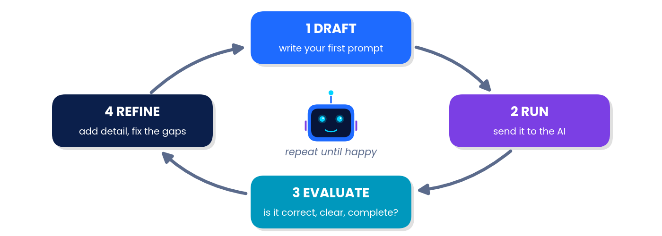
Figure 12.1 – Good prompters rarely stop at the first try.
Round | Prompt | Problem noticed
1 | "Explain recursion." | Too advanced, no examples.
2 | "Explain recursion to a Grade 11 beginner with an everyday example." | Good! But too long.
3 | "Shorten that to 80 words and end with one question I can answer to test myself." | Perfect for revision.

AI BUDDY SAYS
Ask for what you need after you read the answer: *"Simplify the second paragraph"*, *"Give a different example"*, *"Show it as a table"*. Follow-ups are a superpower.

TRY IT YOURSELF
Try it: Take the prompt "Tell me about planets." and improve it in two rounds. Write both versions.

CHAPTER 13 · COMMON PROMPTING MISTAKES
Common Prompting Mistakes and Safe, Smart Use
KEY IDEA | What you will learn
Six frequent mistakes and their fixes · why AI can be confidently wrong · protecting your privacy · using AI honestly in school.

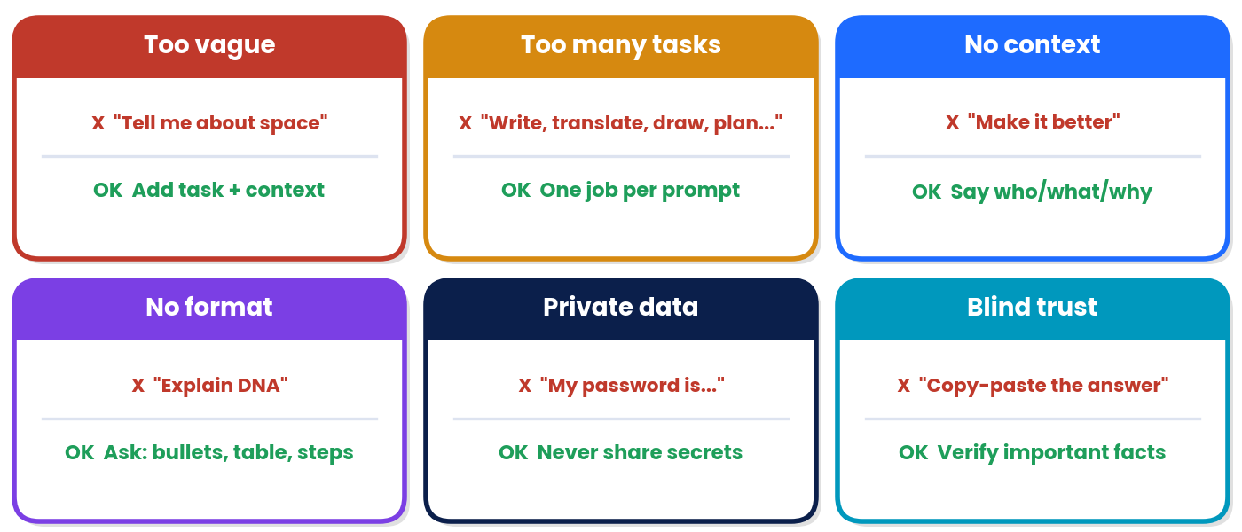
Figure 13.1 – Six common mistakes and how to fix them.
Mistake | Why it hurts | Better prompt
Too vague | The AI must guess your goal | "List 5 causes of the French Revolution for Grade 9, one line each."
Too many tasks | Parts get skipped or done badly | Split into steps: first summarise, then translate, then design.
No context | The AI cannot see what "it" is | Paste the text or code and say what is wrong or what you want.
No format | The answer may be hard to use | "Give the answer as a 3-column table."
Private data | Information may be stored or misused | Remove names, numbers and addresses; ask in general terms.
Blind trust | AI can be wrong or invent facts | Cross-check with textbooks, teachers or trusted sites.

AI can sound sure and still be wrong
AI systems build answers from patterns in data. Sometimes they produce statements that sound fluent and confident but are false, outdated or made up (people call this "hallucination"). They can also reflect bias found in their training data. That is why you, the human, stay in charge: think, check, decide.
REAL-LIFE LINK | A fact-checking routine
1. Spot the claims that matter: numbers, dates, names, quotes.
2. Check them in a textbook, an official website or with a teacher.
3. Ask the AI "How sure are you? What are the limits of this answer?" and read critically.
4. Keep only what you can verify and understand.

Safe and ethical prompting
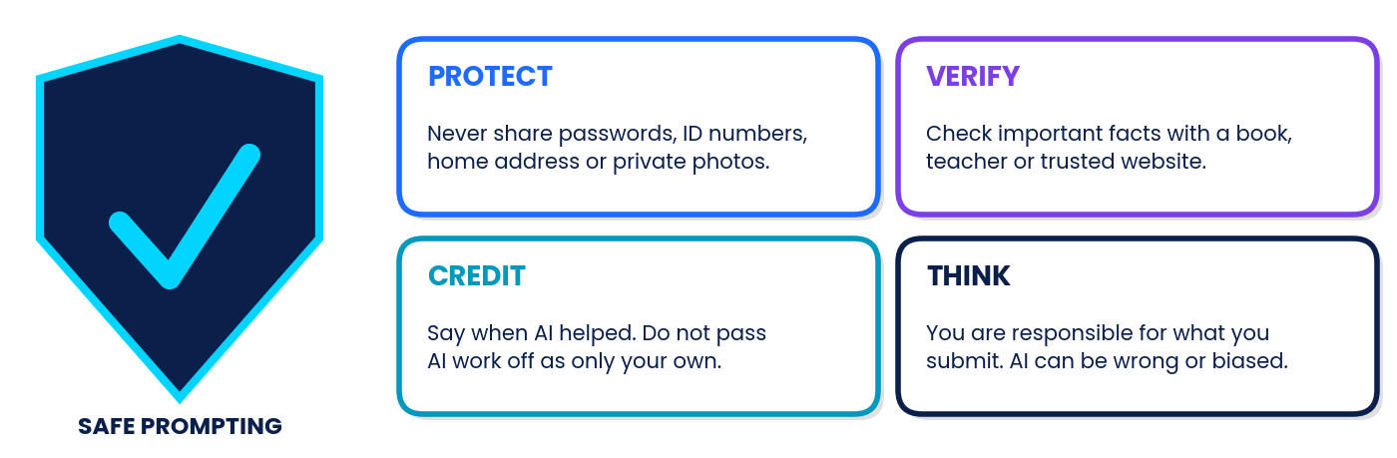
Figure 13.2 – The four habits of a responsible AI user.
- Never share passwords, OTPs, bank or ID numbers, your address or private photos – yours or anyone else's.
- Follow your school rules. If AI help is allowed, say so, and never present AI work as entirely your own.
- Use AI to learn, not to skip learning: ask it to explain, quiz you, or check your reasoning after you try first.
- Be kind and fair. Do not use AI to bully, deceive or spread false information.

TRY IT YOURSELF
Try it: Spot the mistake(s): "Here is my school ID and address. Write my essay, draw my poster, and tell me everything about history."

CHAPTER 14 · PYTHON + PROMPTS
Python and Prompts Together
KEY IDEA | What you will learn
How to ask an AI for coding help · how to verify AI-written code · a worked example of prompt → code → test.

You now know both languages: Python (talk to the computer) and prompts (talk to AI). Together they make a strong learning team. An AI tool can explain error messages, suggest ideas and generate practice problems, but you must understand, run and test every piece of code. Code you do not understand is a risk, not a shortcut.
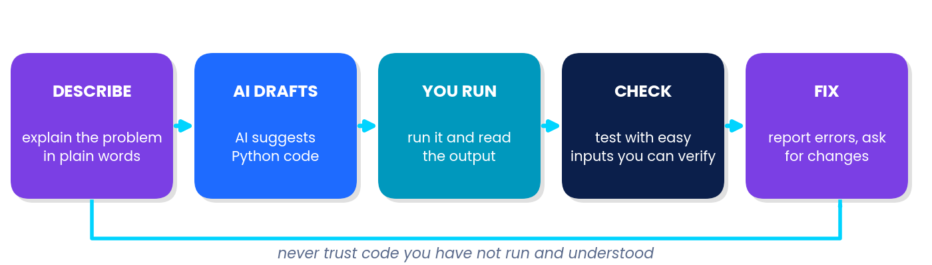
Figure 14.1 – The safe loop for working with AI-written code.

A worked example
REAL-LIFE LINK | Step 1 – A TRACE prompt
"You are a Python tutor. Write a function is_even(n) that returns True if n is even. Audience: Grade 11 beginner. Keep the code under 5 lines and add a comment line. Then show two test calls."

Step 2 – The AI suggests code (a sample reply; wording and code may vary). We now run it ourselves and read the output:
● Step 2 & 3 · run and test the AI's code
def is_even(n):  return n % 2 == 0  print(is_even(10))  print(is_even(7)) | OUTPUT  True  False

Step 4 – Check by hand: 10 is even → True ✔; 7 is odd → False ✔. The results match what we expect, so we can trust this small program. If the output had been wrong, we would send a follow-up prompt such as: __"My test is_even(7) printed True. Here is the code and the output; please find the bug."__

Useful coding prompts
I want to… | Prompt pattern
Understand an error | "Explain this Python error message in simple words and show the fix: [paste error + code]"
Understand code | "Explain this code line by line for a beginner: [paste code]"
Practise | "Give me 5 beginner problems on for loops with increasing difficulty. Do not show answers yet."
Improve | "Suggest clearer variable names for this program, but keep the output the same: [paste]"
Test | "Suggest 4 test inputs for this function, including one tricky case, and the expected outputs."

WATCH OUT | Golden rules for AI + code
Try first. Attempt the problem yourself before asking, so your brain does the learning.
Run everything. Never submit code you have not executed.
Understand every line. If you cannot explain it, ask the AI to explain it.
Follow your teacher's rules on when AI help is allowed.

TRY IT YOURSELF
Try it: Write a prompt asking an AI for 3 practice questions about Python while loops for a Grade 11 beginner, with answers hidden until you ask.


PART C
Practise, Play and Assess
Worksheets · MCQs · Activities · Puzzles · Cases · Project · Assessment

In this part you will… | Self-check: shade a box (1 = not yet, 2 = with help, 3 = confidently)
• complete three worksheets  • answer 30 MCQs  • try five activities and four puzzles  • analyse two case studies  • build the Smart Study Buddy project  • take a 30-mark assessment | Worksheets done ○1 ○2 ○3  MCQs score: __ / 30 ○1 ○2 ○3  Activities completed ○1 ○2 ○3  Puzzles solved ○1 ○2 ○3  Project submitted ○1 ○2 ○3  Assessment score: __ / 30 ○1 ○2 ○3

WORKSHEETS · PRACTISE
Three Worksheets
Write your answers in the spaces. Predict first, then check by running the code on a computer where possible.
WORKSHEET 1  Python Foundations  Variables · Data types · Operators | Name: ____________________  Class/Sec: ________ Date: _______  Marks: ______ / 28

1. Define a variable in one sentence. [1]

2. Tick (✓) the valid Python variable names: my_score, 2nd_place, total-marks, _temp, class, userName. [3]

3. Write the data type (int, float, str or bool) of each value: 25, "25", 2.5, False. [2]

4. State the data type produced by each expression: (a) 7.0 (b) "7" (c) 7 > 3 (d) len("AI") (e) 10 / 2 (f) "3" * 2 [3]

5. Let x = 9 and y = 2. Write the value of: x // y, x % y, x ** y, x / y. [2]

6. Evaluate, showing your steps: (a) 5 + 2 * 3 ** 2 (b) (5 + 2) * 3 ** 2 (c) 20 - 8 / 4 + 1 [3]

7. Trace the code and give the final output. What useful job does it do? [2]
● Code
a = 4
b = 7
a = a + b
b = a - b
a = a - b
print(a, b)

8. Let s = "Prompt". Write the output of: len(s), s.upper(), s[0], s * 2. [2]

9. Each line has one error. Find it and write the corrected line. [3]
● Code
1name = "Sam"
print(Name)
age = "16" + 2

10. Write True or False: (a) 5 == 5.0 (b) "AI" == "ai" (c) 10 != 10 (d) not (4 > 2) [2]

11. Write Python statements to: store your name, your age and a favourite subject in three variables; print all three; then print your age after 5 years. [3]

12. Write the output: int("12") + 3, str(12) + "3", float("2.5") * 2, int(7.9). [2]

WORKSHEET 2  Input, Decisions, Loops & Functions  Input/Output · if-elif-else · for/while · def/return | Name: ____________________  Class/Sec: ________ Date: _______  Marks: ______ / 28

1. Write the output: [1]
● Code
print("A", "B", "C", sep="*")

2. Write the output of the two lines together: [1]
● Code
print("Hi", end="!")
print("Bye")

3. The user types 5. Give the output of the code and the data type of x. [2]
● Code
x = input()
print(x * 2)

4. Write one statement to ask for an age as a whole number, and one print using an f-string to display "Next year you will be __". [2]

5. Predict the output: [1]
● Code
temp = 25
if temp > 30:
print("Hot")
elif temp > 20:
print("Warm")
else:
print("Cool")

6. Write a program that stores a number n = -4 and prints Positive, Negative or Zero. [3]

7. A ticket costs Rs price. If price >= 200 print "Premium", otherwise print "Standard". Write the code for price = 250 and its output. [2]

8. Write the output: [1]
● Code
for i in range(2, 9, 3):
print(i)

9. How many times does the loop run and what does it print? [2]
● Code
n = 1
while n <= 20:
print(n)
n *= 2

10. Write a for loop that prints the even numbers from 2 to 20 on one line. [2]

11. Complete the trace table for the code, then state the final value of total. [3]
● Code
total = 0
for k in range(1, 5):
total = total + k * k

k | k * k | total (after this round)
1
2
3
4

12. Write a function cube(n) that returns the cube of n. Then write a line that prints cube(3) + cube(2) and its result. [3]

13. Explain the difference between print() and return in a function. [2]

14. The function below has three errors. Find and fix them. [3]
● Code
def is_even(n)
if n % 2 = 0:
return True
else
return False

WORKSHEET 3  The Art of Prompting  Prompts · TRACE · techniques · mistakes · safe use | Name: ____________________  Class/Sec: ________ Date: _______  Marks: ______ / 31

1. In your own words, what is a prompt? [1]

2. The TRACE framework has five parts. Write what each letter stands for. [3]

3. Write Vague or Specific for each prompt: (a) "Tell me about space." (b) "List 5 fun facts about the Moon for Grade 6 students, as bullets." (c) "Help me." (d) "Explain photosynthesis in 100 words using a kitchen analogy." [2]

4. Label the TRACE parts in this prompt: "You are a friendly science tutor. Explain what an electric circuit is to a Grade 7 student who has never studied physics. Use a water-pipe analogy, keep it under 120 words, and end with 2 practice questions." [5]

5. Rewrite the weak prompt "Write about my school." as a strong prompt using at least four TRACE parts. Label the parts you use. [4]

6. A prompt says: "Review: *Loved the game!* → Positive. Review: *Too slow and boring.* → Negative. Review: *Best day ever!* → ?" (a) What will the AI most likely answer? (b) Why do the two examples help? [2]

7. Match each technique with its description: Role prompting, Few-shot prompting, Step-by-step prompting, Iterative refinement. [2]
(1) Improve the prompt after reading the answer. (2) Give examples of the pattern wanted. (3) Ask the AI to behave as a particular expert or character. (4) Ask the AI to show its reasoning in order.

8. Name the mistake in each prompt: (a) "Write an essay, translate it into French, draw a poster and plan my holiday." (b) "Make it better." (c) "My bank PIN is 4821 – help me budget." (d) "Tell me everything about climate change." [2]

9. The AI gave you a 400-word answer, but you need 100 words in bullet points. Write a follow-up prompt. [2]

10. Write True or False and correct the false ones: (a) AI answers are always correct. (b) A longer prompt is always better. (c) You can ask an AI to take on a role. (d) Important facts should be checked with a reliable source. [2]

11. List three types of information you should never type into an AI tool, and say why. [3]

12. You want an AI to explain a Python loop you do not understand. Write a complete prompt asking it to explain the code below line by line for a beginner. [3]
● Code
for i in range(3):
print(i * 2)

MULTIPLE-CHOICE QUESTIONS · 30 MCQs
Multiple-Choice Questions
Circle the correct option (A, B, C or D). Questions 1–21 cover Python; 22–30 cover prompting. Score: ______ / 30
1. Which function displays output on the screen?  (A) input()  (B) print()  (C) type()  (D) len() | 16. Which keyword defines a function?  (A) func  (B) define  (C) def  (D) function
2. A single-line comment in Python starts with:  (A) //  (B) /*  (C) #  (D) -- | 17. Which keyword sends a value back from a function?  (A) print  (B) return  (C) give  (D) output
3. Which is a valid variable name?  (A) 2score  (B) total-marks  (C) class  (D) my_score | 18. Running print("Hi) causes which kind of error?  (A) SyntaxError  (B) NameError  (C) ZeroDivisionError  (D) A logic error
4. The data type of the value 3.0 is:  (A) float  (B) int  (C) str  (D) bool | 19. A program runs smoothly but prints a wrong average because the formula is wrong. This is a:  (A) syntax error  (B) runtime error  (C) typing error  (D) logic error
5. What is the value of 17 // 5?  (A) 3.4  (B) 2  (C) 3  (D) 4 | 20. What does bool("") return?  (A) False  (B) True  (C) ""  (D) An error
6. What is the value of 17 % 5?  (A) 2  (B) 3  (C) 12  (D) 85 | 21. What is the type of 7 / 2?  (A) int  (B) str  (C) float  (D) bool
7. What does print("Ab" * 3) display?  (A) Ab3  (B) Ab Ab Ab  (C) An error  (D) AbAbAb | 22. A prompt is:  (A) an error message in Python  (B) the answer an AI returns  (C) a type of variable  (D) an instruction or question given to an AI
8. input() always returns data of type:  (A) int  (B) str  (C) float  (D) bool | 23. Which is the most specific prompt?  (A) "Tell me about trees."  (B) "Explain photosynthesis in 5 bullet points for a Grade 7 student."  (C) "Science please."  (D) "Write something about plants."
9. Which expression turns the text "25" into the number 25?  (A) str("25")  (B) bool("25")  (C) int("25")  (D) type("25") | 24. In TRACE, the letter A stands for:  (A) Answer  (B) Accuracy  (C) Audience & context  (D) Algorithm
10. What is the value of 10 > 5 and 3 > 8?  (A) True  (B) 3  (C) Error  (D) False | 25. Few-shot prompting means:  (A) giving a few examples inside the prompt  (B) sending the prompt a few times  (C) using very few words  (D) asking only short questions
11. Which keyword adds a second condition after if?  (A) elif  (B) else if  (C) elseif  (D) then | 26. Why might you begin a prompt with "You are a friendly maths tutor"?  (A) It makes the AI faster  (B) It changes the AI's code  (C) It hides the task  (D) It guides the tone and viewpoint of the answer
12. After x = 5 and x += 3, the value of x is:  (A) 5  (B) 15  (C) 8  (D) 53 | 27. The AI quotes a surprising statistic. The best next step is to:  (A) assume it is correct  (B) check it with a reliable source  (C) delete the chat  (D) share it immediately
13. range(1, 10, 3) produces:  (A) 1, 4, 7, 10  (B) 1, 4, 7  (C) 1, 3, 6, 9  (D) 3, 6, 9 | 28. Iterative prompting means:  (A) improving your prompt after reading each response  (B) using loops in Python  (C) writing prompts in capitals  (D) using only one prompt ever
14. How many times does the body of for i in range(4): run?  (A) 4  (B) 3  (C) 5  (D) Forever | 29. Which is a prompt-writing mistake?  (A) Stating the audience  (B) Asking for a table  (C) Typing your password to get help  (D) Giving context
15. Which statement ends a loop immediately?  (A) stop  (B) exit  (C) continue  (D) break | 30. Adding "Explain step by step" to a prompt mainly helps to:  (A) get a shorter answer  (B) hide mistakes  (C) avoid giving context  (D) see the reasoning in order

CLASSROOM ACTIVITIES · LEARN BY DOING
Five Classroom Activities

Activity 1: Human Interpreter
Type: Unplugged | Time: 20 min | Group: Groups of 4 | You need: paper, 3 sticky notes, pen

- Roles: Reader (reads one line at a time), Variable Keeper (writes each variable on a sticky note and crosses out old values), Calculator, and Output Scribe (writes every printed line).
- Run Program 1 as the computer: total = 0 / for k in range(1, 4): / total = total + k * 2 / print(total)
- Run Program 2: n = 20 / while n > 5: / n = n - 6 / print(n)
- Swap roles and compare your outputs with another group. Then check on a real computer.
KEY IDEA | Discuss
Which step is easiest to get wrong? Why do computers never get tired of repeating steps?

Activity 2: Be the AI
Type: Unplugged | Time: 25 min | Group: Pairs | You need: paper, pencils, TRACE card

- Round 1: Partner A writes the prompt "Draw an animal." on a card. Partner B is "the AI" and must follow only the words. Compare the drawing with what A imagined.
- Round 2: A rewrites the prompt with TRACE, e.g. "Draw a smiling cat sitting on a blue chair, side view, using 5 lines." B draws again.
- Round 3: Swap roles. Write a prompt for "a healthy lunch plan" and score each other: 1 mark each for Task, Role, Audience, Constraints, Format (out of 5).
- Extension (if your school allows AI tools, teacher supervised): try the Round 1 and Round 2 prompts on a chatbot and compare the answers.
KEY IDEA | Discuss
How did extra detail change the result? What did the "AI" have to guess?

Activity 3: Flowchart Floor Walk
Type: Unplugged | Time: 25 min | Group: Whole class | You need: chalk or masking tape, number cards

- Draw the grade-ladder flowchart (Figure 6.1) large on the floor: START, three diamonds, boxes for grades and an END.
- A "Program" student walks the path. A "Judge" holds a marks card (82, 55, 30, 75) and answers True or False at each diamond.
- Record the grade each walker ends with. Then make a loop: a walker repeats a "say the number" box until the counter card reaches 5.
- Check: what happens at exactly 75? Which diamond catches it?
KEY IDEA | Discuss
Why does only one branch run in if-elif-else?

Activity 4: Debug Detective
Type: Paper or computer | Time: 30 min | Group: Pairs | You need: the 5 cases below

- Case 1: name = input("Name: ") / print("Hello" name)
- Case 2: for i in range(3) / print(i)
- Case 3: age = input("Age: ") / if age >= 18: / print("Adult") (user types 20)
- Case 4: total = 0 / for n in range(1, 5): / total = total + n / print(total) (should print 15, the sum of 1 to 5)
- Case 5: def double(x): / x * 2 / print(double(4)) (should print 8)
- For each case decide: syntax, runtime or logic error? Then write the fix and test it.
KEY IDEA | Discuss
Which bugs did the computer report by itself? Which ones needed your thinking?

Activity 5: Build-a-Bot
Type: Computer | Time: 35 min | Group: Pairs | You need: Program 9.3 (chatbot)

- Copy Program 9.3. Add two new keyword rules of your own (for example "exam" and "thanks").
- Write a test table with 5 messages and the reply you expect. Run the program and tick which tests pass.
- Swap computers with another pair. Try to break their bot with a tricky message.
- Reflect: type print("hi" in "this is nice"). Why might keyword matching misunderstand people?
KEY IDEA | Discuss
How is this rule-based bot different from a modern AI chatbot? Why is testing important?

PUZZLES AND BRAIN GAMES · PLAY
Four Puzzles and Brain Games

Puzzle 1 · Word Search: Python and Prompt Words
Find the 12 hidden words. They can run across, down, diagonally, and some are backwards.
 | WORD BANK  ☐ PYTHON  ☐ VARIABLE  ☐ LOOP  ☐ STRING  ☐ PROMPT  ☐ INPUT  ☐ BOOLEAN  ☐ FLOAT  ☐ DEBUG  ☐ TRACE  ☐ FUNCTION  ☐ ROLE
  Q | V | N | R | H | U | Z | F | L | O | A | T
  W | Q | O | H | Q | U | A | M | V | S | Z | K
  V | U | D | E | B | U | G | N | B | X | J | E
  L | O | O | P | G | B | N | O | H | T | Y | P
  J | T | T | C | N | O | I | T | C | N | U | F
  C | R | P | J | J | X | F | N | S | I | E | A
  R | A | M | B | S | G | N | I | R | T | S | G
  S | C | O | E | L | B | A | I | R | A | V | R
  O | E | R | B | O | O | L | E | A | N | F | O
  Y | W | P | T | Q | B | M | G | L | D | G | L
  S | I | N | P | U | T | V | N | S | G | P | E
  D | V | M | J | Q | P | A | K | T | M | J | A

Puzzle 2 · Code-Breaker: The Shift-3 Cipher
Each letter has been moved 3 places forward in the alphabet (A→D, B→E …, X→A). To decode, move each letter 3 places back.
Plain | A | B | C | D | E | F | G | H | I | J | K | L | M
Cipher | D | E | F | G | H | I | J | K | L | M | N | O | P
Plain | N | O | P | Q | R | S | T | U | V | W | X | Y | Z
Cipher | Q | R | S | T | U | V | W | X | Y | Z | A | B | C

(a) Decode the three words: SURPSW ORRS GHEXJ → ____________ ______ ________
(b) Decode the secret rule for good prompts: EH FOHDU DQG VSHFLILF

Puzzle 3 · Output Match-Up
Work out what each snippet prints (no computer!). Draw a line or write the matching number.
Snippet | Code | No. | Possible output | A–F matches →
A | x = 3  x = x * 2 + 1  print(x) | 1 | 4
B | for i in range(3):  print(i, end=" ") | 2 | False True
C | print("AI" * 2 + "!") | 3 | AIAI!
D | n = 10  while n > 4:  n -= 3  print(n) | 4 | 7
E | word = "robot"  print(word[1] + word[-1]) | 5 | ot
F | print(7 > 3 and 2 > 5, 7 > 3 or 2 > 5) | 6 | 0 1 2

Puzzle 4 · Prompt Detective (logic grid)
Four students each made one different prompting mistake: vague, too many tasks, private data or no format. Use the clues to match each student to a mistake. Put ✔ or ✘ in the grid.
- Asha did not write the too-many-tasks prompt, and she did not share private data.
- Ben's prompt was neither vague nor too-many-tasks.
- Chitra's mistake was neither "vague" nor "private data".
- Dev did not write the "no format" prompt, and he did not share private data.
- Asha's prompt was not vague.

 | Vague | Too many tasks | Private data | No format
Asha
Ben
Chitra
Dev

QUICK QUIZ · 5 MINUTES
Quick Quiz
Write the answer in the box. Score: ______ / 10
No. | Question | Answer
1 | True or False: Python treats Score and score as different names.
2 | Fill in the blank: the operator that gives the remainder is ______ .
3 | True or False: "5" + "5" gives 10.
4 | Fill in the blank: a ______ loop is best when the number of repeats is known.
5 | True or False: A Python function must always return a value.
6 | In TRACE, the letter C stands for ______ .
7 | True or False: A longer prompt is always a better prompt.
8 | Fill in the blank: giving examples inside a prompt is called ______ prompting.
9 | What does print(2 ** 3) display?
10 | True or False: Important facts from an AI should be verified.

CASE STUDY 1
The Canteen Billing Bot

The school canteen wants to stop adding bills by hand. A student writes this program. Items, prices (Rs) and quantities are stored in three lists, and orders above Rs 150 get a 10% discount.
● canteen_bill.py
items = ["Sandwich", "Juice", "Fruit Bowl"]  prices = [40, 25, 30]  qty = [2, 1, 3]  total = 0  for i in range(len(items)):  cost = prices[i] * qty[i]  print(items[i], "x", qty[i], "=", cost)  total += cost  print("Total:", total)  if total > 150:  discount = total * 0.10  total = total - discount  print("Discount applied: Rs", discount)  print("Final bill: Rs", total) | OUTPUT  Sandwich x 2 = 80  Juice x 1 = 25  Fruit Bowl x 3 = 90  Total: 195  Discount applied: Rs 19.5  Final bill: Rs 175.5

Q1. (a) Explain what range(len(items)) does in the loop. [2]

Q2. (b) What was the total before the discount, and why was the discount applied? [2]

Q3. (c) If the Juice quantity changes to 4 (other quantities unchanged), what will "Final bill" be? Show your working. [2]

Q4. (d) Suggest one improvement using input() or a function. [2]

Q5. (e) List four Python concepts used in this program. [2]

CASE STUDY 2
Neha's Science Exhibition

Neha must give a 2-minute talk at the school science exhibition. She tries three prompts. (Descriptions of the AI replies are illustrative samples; real replies vary.)
Attempt | Neha's prompt | What the AI returned
1 | "Tell me about solar energy." | A long, general essay (about 600 words) covering history, panels, costs and policy. Too broad to speak in 2 minutes.
2 | "Explain solar energy for my science exhibition." | A shorter text, but still general, difficult words, no clear audience or time limit.
3 | "You are a science communicator. Help me prepare a 2-minute talk on how solar panels turn sunlight into electricity for visitors who are not scientists. Use an everyday analogy, keep it under 200 words, and finish with 3 likely visitor questions with short answers." | A focused talk of about 180 words with a water-slide analogy and 3 Q&As. Neha also noticed one number in the talk that she could not find in her textbook.

Q1. (a) Give two reasons why Attempt 1 was a weak prompt. [2]

Q2. (b) Identify the TRACE parts used in Attempt 3 (Role, Task, Audience, Constraints, Format). [3]

Q3. (c) Suggest two ways Neha can check the number she could not find in her textbook. [2]

Q4. (d) Should Neha present the AI's talk exactly as her own work? Explain. [2]

Q5. (e) Write a follow-up prompt to make the talk friendlier for younger visitors. [1]

MINI-PROJECT · 20 MARKS
Smart Study Buddy
Goal: build a Python program that helps a student track marks, and use AI prompts to support your study plan. You will combine variables, input, loops, functions and decisions with prompt skills.
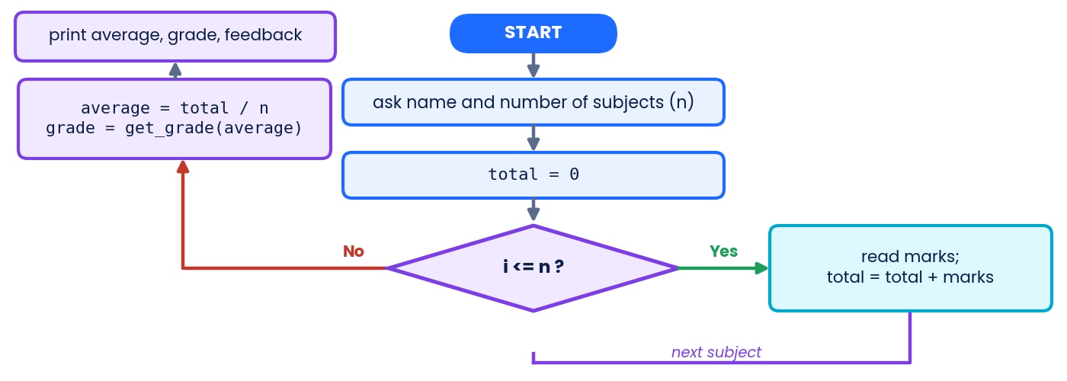
Figure P.1 – Plan of the Smart Study Buddy program.

Part 1 · The program (8 marks)
- Ask for the student's name and how many subjects (int).
- Use a loop to read each subject's marks (float).
- Write a function get_grade(avg) that returns A+ (90 and above), A (75–89), B (60–74), C (40–59) or "Needs improvement".
- Print the average with one decimal place using an f-string, the grade, and a feedback message chosen with if-else.
● Starter code (fill the blanks)
def get_grade(avg):
if avg >= 90:
return "A+"
elif avg >= ____:
return "A"
# add the B, C and last cases here

name = input("Your name: ")
n = int(input("How many subjects? "))
total = 0
for i in range(1, n + 1):
m = float(input(f"Marks in subject {i}: "))
total = ____ + m
average = total / ____
# print the results here

Part 2 · Prompt portfolio (6 marks)
Task for the AI | My TRACE prompt | What I changed after reading the answer | Rating /5
Make a 5-day revision plan for my weakest subject
Explain my get_grade function line by line
Create 5 practice questions on loops (answers hidden)

Part 3 · Testing and debugging log (3 marks)
Test input (marks) | Expected output | Actual output | Pass?

Part 4 · Reflection (3 marks)
What was the hardest bug? How did your prompts improve between the first and last try? How did you verify the AI's help?

Rubric | 4 – 3 marks | 2 – 1 marks | 0 marks
Program (8) | Runs correctly, uses loop, function, f-string, if-else | Runs with small errors or misses one required feature | Does not run
Prompts (6) | Three clear TRACE prompts with improvements recorded | Prompts lack detail; few improvements | Missing
Testing (3) | 3 tests with correct expected values | 1–2 tests | None
Reflection (3) | Honest, specific, mentions verification | General comments | Missing

CHAPTER ASSESSMENT · 30 MARKS
Unit 2 Chapter Assessment
Time: 45 minutes | Total marks: 30 | Name: ____________________ | Score: ______ / 30
Section A: 6 × 1 = 6 · Section B: 5 × 2 = 10 · Section C: 3 × 3 = 9 · Section D: 5 (total 30). Write code neatly with correct indentation.

Section A – Multiple Choice [6 marks]
1. Which of these is a valid variable name?  (A) _total  (B) 9lives  (C) my score  (D) for | 4. Which statement skips the rest of the current loop round and moves on to the next one?  (A) break  (B) stop  (C) continue  (D) pass
2. What is the value of 2 + 3 * 2 ** 2?  (A) 14  (B) 20  (C) 50  (D) 16 | 5. In the TRACE framework, E stands for:  (A) Example  (B) Expected format  (C) Error  (D) Evaluation
3. What is displayed by print(type(5 > 3))?  (A) <class 'bool'>  (B) <class 'int'>  (C) <class 'str'>  (D) True | 6. An AI gives a surprising statistic in its answer. What is the best action?  (A) Copy it into your homework at once  (B) Ask the AI to say it louder  (C) Check it with a reliable source  (D) Ignore all AI answers forever

Section B – Short Answer [10 marks]
7. Differentiate between = and == with one example of each. [2]

8. State two differences between a for loop and a while loop. [2]

9. Write the exact output of this code: [2]
● Code
print("AI", "is", "fun", sep="-", end="!")
print("Yes")

10. The code below gives an error when the user types 15. Name the error and rewrite the second line to fix it. [2]
● Code
age = input("Age: ")
print(age + 1)

11. Define prompt engineering and give one benefit of learning it. [2]

Section C – Applied Questions [9 marks]
12. Find the output of the code, and state how many times the line total += n is executed. [3]
● Code
total = 0
for n in range(1, 8):
if n % 3 == 0:
continue
total += n
print(total)

13. Write a function ticket_price(age) that returns 0 if age is below 5, 50 if age is 5 to 17, and 100 otherwise. [3]

14. Rewrite the weak prompt "Explain photosynthesis." as a strong prompt using at least four TRACE parts. Label each part you use. [3]

Section D – Case-Based Question [5 marks]
15. Arjun writes a program to find the average of three marks, but his result looks wrong.
● Arjun's code
m1 = 60
m2 = 75
m3 = 90
avg = m1 + m2 + m3 / 3
print(avg)

(a). What kind of error is this (syntax, runtime or logic)? Give a reason. [1]

(b). Write the exact output Arjun sees. [1]

(c). Write the corrected line so that the program prints the true average. [1]

(d). Arjun asks an AI for help. Write a clear prompt that uses at least two TRACE parts. [2]

CHAPTER SUMMARY · REVISE
Summary, Concept Map and Revision
Topic | Remember this
Python basics | print() shows output; # starts a comment; Python is case-sensitive; indentation groups code; errors are syntax, runtime or logic.
Variables | A named box for a value: score = 10. Names: letters, digits, _; not starting with a digit; no keywords.
Data types | int whole, float decimal, str text, bool True/False. Convert with int(), float(), str(); check with type().
Operators | Arithmetic + - * / // % **; comparison == != > < >= <=; logical and or not; assignment = += -=. Brackets first, then **, then * / // %, then + -.
Input / Output | input() returns text; convert before calculating. print(..., sep=, end=) and f-strings f"{x}".
Decisions | if / elif / else: first True branch runs. Colon and 4-space indent. == compares, = assigns.
Loops | for for known repeats (range(start, stop, step)); while while a condition is True; break exits; continue skips.
Functions | def name(parameters): … return value. Variables inside are local. return gives back, print only shows.
Prompts | A prompt is the instruction you give an AI. TRACE = Task, Role, Audience & context, Constraints, Expected format.
Techniques | Be specific, give context, assign a role, show examples (few-shot), ask for steps, control format, iterate.
Mistakes & safety | Avoid vague prompts, too many tasks, missing context, no format, private data and blind trust. Always verify important facts.

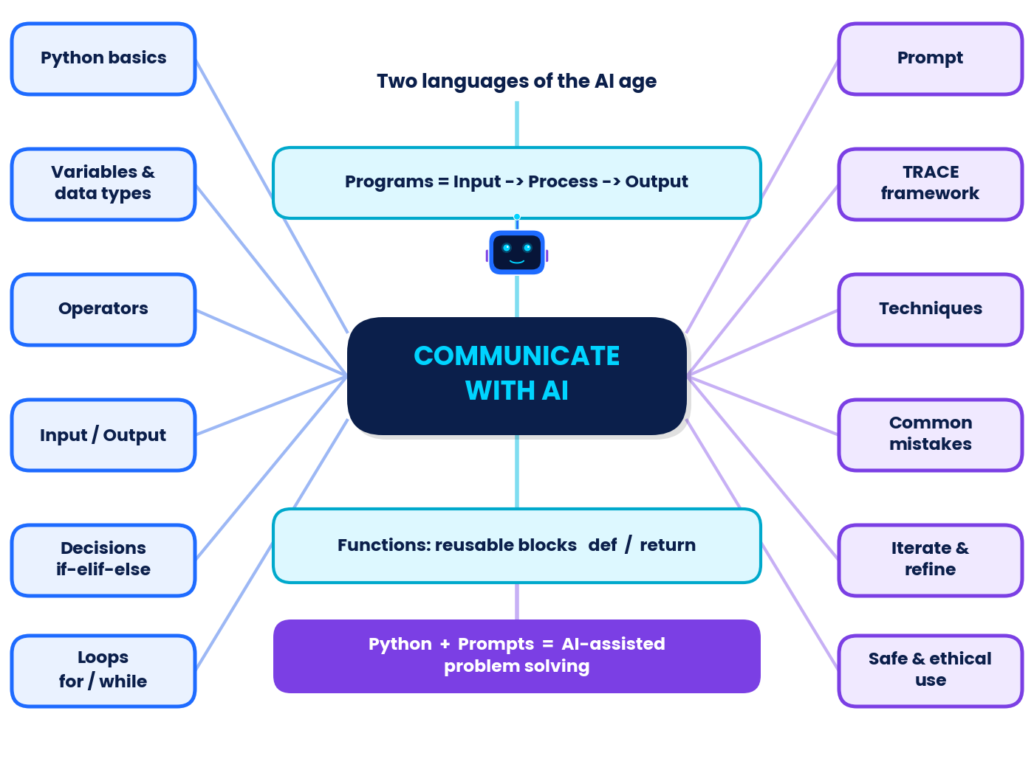
Concept map of Unit 2.

Revision exercises
A. Fill in the blanks using the word bank: constraints, for, function, variable, f-string, comment, prompt, modulus.
- A ______ stores a value under a name.
- Text written after # is ignored; it is called a ______.
- The ______ operator % gives the remainder of a division.
- A ______ loop is used when the number of repetitions is known.
- A reusable block of code created with def is a ______.
- Putting the letter f before a string creates an ______.
- The instruction you give to an AI is called a ______.
- Asking for "100 words in a formal tone" adds ______ to a prompt.
B. Coding drills. Write the output of each program, then run to check.
● Drill 1
nums = [4, 9, 2, 7]
biggest = nums[0]
for n in nums:
if n > biggest:
biggest = n
print(biggest)

● Drill 2
def double_all(a, b):
return a * 2, b * 2

x, y = double_all(3, 5)
print(x + y)

● Drill 3
word = "python"
count = 0
for ch in word:
if ch in "aeiou":
count += 1
print(count)

Drill 4. Write a loop that prints the squares of 1 to 5, one per line.

C. Prompt practice.
- Write a TRACE prompt asking an AI to create 5 practice questions on Python loops for a Grade 11 beginner, with answers hidden until you ask.
- This prompt has two mistakes: "Do my project and my friend's project too. My address is 12 Lake Road." Name both and rewrite it.
- In two sentences, explain why you should run AI-written code before trusting it.

GLOSSARY · KEY TERMS
Glossary
Term | Meaning | Term | Meaning
Argument | Actual value passed to a function when it is called. | Index | Position of an item, starting at 0.
Bias | Unfair tendency in AI answers, often from the data it learned from. | Input | Data entered into a program.
Bool | Data type with only True or False. | Int | Whole number.
break | Statement that exits a loop immediately. | Logic error | Program runs but gives a wrong result.
Bug | A mistake in a program. | Loop | Structure that repeats instructions.
Comment | Text after # ignored by Python. | Operator | Symbol that acts on values, e.g. +.
Condition | Expression that is True or False. | Parameter | Placeholder name in a function definition.
Constraint | A limit in a prompt, such as length or tone. | Prompt | Instruction or question given to an AI.
continue | Skips the rest of the current loop round. | Prompt engineering | Designing and improving prompts for better responses.
Data type | The kind of data a value is (int, float, str, bool). | range() | Generates a sequence of numbers.
Debugging | Finding and fixing bugs. | Response | The AI's reply to a prompt.
def | Keyword that defines a function. | return | Sends a value back from a function.
elif | "Else if": another condition after if. | Role prompting | Telling the AI which role to play.
f-string | String with f prefix that inserts values using { }. | Runtime error | Error that appears while the program runs.
Few-shot prompting | Giving examples inside a prompt. | String | Text data in quotes.
Float | Number with a decimal part. | Syntax error | Broken grammar of the code.
Function | Named reusable block of code. | TRACE | Task, Role, Audience & context, Constraints, Expected format.
Hallucination | A confident but false or invented AI statement. | Variable | Named storage for a value.


PART D
Teacher Answer Key
Answers · explanations · marking schemes (teachers only)

In this part you will… | Self-check: shade a box (1 = not yet, 2 = with help, 3 = confidently)
• mark all worksheets and MCQs  • run activities and puzzles with confidence  • use rubrics for the project  • mark the assessment out of exactly 30 | Marking principles read ○1 ○2 ○3  Key checked against outputs ○1 ○2 ○3  Rubric shared with class ○1 ○2 ○3

TEACHER GUIDE · USING THIS KEY
Teacher Guide and Marking Notes
Section | Marks | Suggested time
Worksheet 1 – Python foundations | 28 | 35 min
Worksheet 2 – Input, decisions, loops, functions | 28 | 45 min
Worksheet 3 – The art of prompting | 31 | 35 min
30 MCQs | 30 | 30 min
Quick quiz | 10 | 5 min
Case studies (2 × 10) | 20 | 40 min
Mini-project | 20 | 2 lessons
Chapter assessment | 30 | 45 min

KEY IDEA | Marking principles
Method marks: where an answer shows correct working but a small slip, award the method mark. Half marks (0.5) are allowed in worksheets; round the worksheet total up.
Code answers: accept any correct variable names, spacing and quote style. Deduct only for logic errors, missing colons or wrong indentation, and award the other marks.
Prompt answers: accept any reasonable wording. Judge by TRACE content, not by length.
AI sample outputs shown in the book are illustrative; real responses will differ. All Python outputs were produced by running the code (Python 3).
Assessment totals: A = 6, B = 10, C = 9, D = 5, giving exactly 30 marks.

Answers to the "Try it yourself" boxes
Chapter | Suggested answer
Ch 1 | Any two-line introduction using print(). Removing a quote gives a SyntaxError such as "unterminated string literal"; restoring it fixes the error.
Ch 2 | Example: city = "Pune", temperature = 31, is_sunny = True; temperature = temperature + 2 prints 33.
Ch 3 | Outputs: <class 'str'>, <class 'float'>, and 1010 (the text "10" repeated twice).
Ch 4 | 13, 20, 3, 32.
Ch 5 | name = input("Name: "); hours = float(input("Hours: ")); print(f"{name} studied {hours} hours today."). Accept int() for whole hours.
Ch 6 | if t < 15: print("Cold"), elif t <= 30: print("Pleasant"), else: print("Hot").
Ch 7 | for n in range(1, 6): print(n * n) prints 1 4 9 16 25. n = 10 / while n >= 2: print(n); n -= 2.
Ch 8 | def average(a, b): return (a + b) / 2 and print(average(70, 80)) prints 75.0.
Ch 9 | Add elif "thanks" in message: followed by return "You are welcome!" before the final else. (Remember message has been converted to lower case.)
Ch 10 | Sample: vague "Help me with my science project." Improved: "Suggest 3 low-cost Grade 11 physics project ideas I can finish in two weeks, with a one-line plan for each." Extra details: subject, grade, cost limit, time limit, number of ideas, format.
Ch 11 | Role: career counsellor. Task: suggest three careers in AI. Audience/context: Grade 11 student who likes maths. Constraints: one line each. Expected format: table.
Ch 12 | Sample round 1: "Describe the 8 planets for a Grade 6 student." Round 2: "Describe the 8 planets for a Grade 6 student in a table with name, size rank and one fun fact; keep each fact under 12 words."
Ch 13 | Mistakes: shares private information; too many tasks; too vague/broad ("everything about history"); also asks AI to do the work instead of helping the student learn.
Ch 14 | Sample: "You are a Python tutor. Give me 3 practice questions on while loops for a Grade 11 beginner, easy to medium. Do not show the answers until I ask."

ANSWER KEY · WORKSHEET 1
Worksheet 1 Key: Python Foundations (28 marks)
Q [marks] | Answer | Explanation / marking
1  [1] | A named location in memory that stores a value, which can change while the program runs. | 1 mark: "named", "stores a value", or "memory location" idea.
2  [3] | Valid: my_score, _temp, userName. | 2nd_place starts with a digit; total-marks contains a hyphen; class is a reserved keyword. 0.5 mark per name classified correctly.
3  [2] | 25 → int; "25" → str; 2.5 → float; False → bool. | Quotes make "25" text. 0.5 mark each.
4  [3] | (a) float (b) str (c) bool (d) int (e) float (f) str | 10 / 2 gives 5.0 (division always gives float). "3" * 2 repeats text and gives "33". 0.5 mark each.
5  [2] | 4, 1, 81, 4.5 | Verified output of print(x + y, x // y, x % y, x ** y, x / y) is "11 4 1 81 4.5". 0.5 mark each.
6  [3] | (a) 23 (b) 63 (c) 19.0 | (a) 3**2 = 9, 2*9 = 18, 5+18 = 23. (b) 7 * 9 = 63. (c) 8/4 = 2.0, 20 - 2.0 = 18.0, +1 = 19.0. 1 mark each (method + answer).
7  [2] | Output: 7 4. It swaps the values of a and b. | a = 11, then b = 11 - 7 = 4, then a = 11 - 4 = 7. 1 mark output, 1 mark for "swaps".
8  [2] | 6, PROMPT, P, PromptPrompt | Index 0 is the first character. 0.5 mark each.
9  [3] | 1) name1 = "Sam" (a name cannot start with a digit).  2) print(name) (Python is case-sensitive; Name was never defined, so it raises NameError).  3) age = int("16") + 2 (cannot add text and a number; result 18). | 1 mark per line: error identified + valid correction.
10  [2] | (a) True (b) False (c) False (d) False | 5 == 5.0 compares values, so True. Strings are case-sensitive, so "AI" and "ai" differ. 0.5 mark each.
11  [3] | Model answer:  name = "Riya"  age = 16  subject = "AI"  print(name, age, subject)  print(age + 5) | Any valid names/values. 1 mark variables, 1 mark print, 1 mark age + 5 (no quotes around age).
12  [2] | 15, 123 (the text "123"), 5.0, 7 | Verified: 15 123 5.0 7. int() cuts off the decimal part; it does not round. 0.5 mark each.

ANSWER KEY · WORKSHEET 2
Worksheet 2 Key: Input, Decisions, Loops & Functions (28 marks)
Q [marks] | Answer | Explanation / marking
1  [1] | A*B*C | sep is placed between the items.
2  [1] | Hi!Bye | end="!" replaces the usual new line, so "Bye" continues on the same line.
3  [2] | Output: 55 (the text "5" repeated twice). Data type: str. | input() always returns text. 1 mark output, 1 mark type.
4  [2] | age = int(input("Age: "))  print(f"Next year you will be {age + 1}.") | 1 mark int(input()), 1 mark correct f-string with {age + 1}.
5  [1] | Warm | 25 > 30 is False; 25 > 20 is True, so "Warm" runs and the rest is skipped.
6  [3] | n = -4  if n > 0:  print("Positive")  elif n < 0:  print("Negative")  else:  print("Zero")  Output: Negative | 1 mark correct conditions, 1 mark colons/indentation, 1 mark correct output (verified: Negative).
7  [2] | price = 250  if price >= 200:  print("Premium")  else:  print("Standard")  Output: Premium | 1 mark if-else structure, 1 mark output.
8  [1] | 2, 5, 8 (one per line) | Starts at 2, adds 3 each time, stops before 9: 2, 5, 8.
9  [2] | Runs 5 times; prints 1, 2, 4, 8, 16. | After 16, n becomes 32 and 32 <= 20 is False. 1 mark count, 1 mark values.
10  [2] | for n in range(2, 21, 2):  print(n, end=" ")  Output: 2 4 6 8 10 12 14 16 18 20 | stop must be 21 so that 20 is included. 1 mark range, 1 mark print.
11  [3] | k = 1 → 1; k = 2 → 5; k = 3 → 14; k = 4 → 30. Final total = 30. | Verified output: 1 1 2 5 3 14 4 30. 0.5 mark per row + 1 mark final value.
12  [3] | def cube(n):  return n ** 3  print(cube(3) + cube(2))  Output: 35 | 27 + 8 = 35. 1 mark def line with colon, 1 mark return, 1 mark call and result.
13  [2] | print() only shows a value on the screen. return sends a value back to the caller so it can be stored or used in more calculations. | 1 mark each side. Example: x = square(4) works with return; with print, x would be None.
14  [3] | 1) Missing colon after def is_even(n).  2) = is assignment; the comparison must be ==.  3) Missing colon after else. | Verified: the error-free version prints "True False" for is_even(8), is_even(5). 1 mark per error.

Trace table for Worksheet 2, Q11
k | k * k | total
1 | 1 | 1
2 | 4 | 5
3 | 9 | 14
4 | 16 | 30

ANSWER KEY · WORKSHEET 3
Worksheet 3 Key: The Art of Prompting (31 marks)
Q [marks] | Answer | Explanation / marking
1  [1] | The instruction, question or information that a person gives to an AI system to get a response. | 1 mark for "input/instruction given to an AI".
2  [3] | T – Task; R – Role; A – Audience & context; C – Constraints; E – Expected format. | 5 correct = 3 marks; 3–4 correct = 2 marks; 1–2 correct = 1 mark.
3  [2] | (a) Vague (b) Specific (c) Vague (d) Specific | Specific prompts name the task, audience, length or format. 0.5 mark each.
4  [5] | Role: "friendly science tutor"  Task: "Explain what an electric circuit is"  Audience & context: "Grade 7 student who has never studied physics"  Constraints: "water-pipe analogy", "under 120 words"  Expected format: "end with 2 practice questions" | 1 mark per correctly labelled part. Accept "analogy" under either Constraints or Task if justified.
5  [4] | Model: "[Role] You are a school-magazine editor. [Task] Write a welcome paragraph about my school. [Audience] for new Grade 9 students and their parents. [Constraints] Friendly tone, about 80 words, mention our science lab and football ground. [Format] Give two headline options first, then the paragraph." | 1 mark per TRACE part used correctly (max 4). Accept any sensible content.
6  [2] | (a) Positive. (b) The examples show the pattern and the answer format the AI should follow (this is few-shot prompting). | 1 mark each part.
7  [2] | Role prompting → 3; Few-shot → 2; Step-by-step → 4; Iterative refinement → 1. | 0.5 mark each.
8  [2] | (a) Too many tasks in one prompt (b) No context (what is "it"? better how?) (c) Sharing private/sensitive information (d) Too broad / vague | 0.5 mark each.
9  [2] | Model: "Please shorten your answer to about 100 words and present it as 5 bullet points, keeping the key facts." | 1 mark for length constraint, 1 mark for format request.
10  [2] | (a) False – AI can be wrong or make things up. (b) False – clear and relevant beats long. (c) True. (d) True. | 0.5 mark each.
11  [3] | Any three of: passwords/PINs, ID or bank numbers, home address/phone number, private photos, other people's personal details. Why: the information may be stored or leaked and misused, and it cannot be taken back. | 1 mark per item; reason can be awarded within any item.
12  [3] | Model: "You are a patient Python tutor. Explain this code line by line to a Grade 11 beginner: for i in range(3): print(i * 2). Use simple words, keep it under 100 words, and finish by showing the exact output." (Output: 0, 2, 4.) | 1 mark role/audience, 1 mark includes the code, 1 mark constraint or format.

ANSWER KEY · MCQS AND QUICK QUIZ
MCQ Key (30 × 1 = 30 marks)
Q | Ans | Why | Q | Ans | Why
1 | B | print() shows values; input() reads them. | 16 | C | Functions begin with def name(parameters):.
2 | C | # marks a comment; Python ignores the rest of that line. | 17 | B | return hands the result back to the caller.
3 | D | Names cannot start with a digit, contain hyphens or be keywords. | 18 | A | The string is missing its closing quotation mark, which breaks the grammar of the language.
4 | A | It has a decimal point, so it is a float. | 19 | D | Nothing crashes, but the reasoning is wrong.
5 | C | Floor division gives the whole-number part of 3.4, which is 3. | 20 | A | An empty string is "falsy"; any non-empty string is True.
6 | A | 17 = 3 × 5 + 2, so the remainder is 2. | 21 | C | The / operator always gives a float (3.5).
7 | D | The * operator repeats a string. | 22 | D | The prompt is what you give; the response is what you get back.
8 | B | Whatever the user types arrives as text; convert with int() or float(). | 23 | B | It has a task, audience and format.
9 | C | int() converts text that looks like a whole number into an integer. | 24 | C | A tells the AI who the answer is for and what they already know.
10 | D | and needs both sides True; 3 > 8 is False. | 25 | A | Examples show the pattern or format you want.
11 | A | Python uses the single keyword elif. | 26 | D | This is role prompting.
12 | C | x += 3 means x = x + 3. | 27 | B | AI can produce confident but wrong statements.
13 | B | Start 1, step 3, stop before 10: 1, 4, 7. | 28 | A | Draft → run → evaluate → refine.
14 | A | i takes the values 0, 1, 2, 3. | 29 | C | Never share passwords or private data.
15 | D | break leaves the loop; continue only skips to the next round. | 30 | D | It makes the AI lay out the steps so you can check them.
Verification run: 17 // 5 and 17 % 5 → 3 2; "Ab" * 3 → AbAbAb; type(7 / 2) → float.

Quick Quiz key (10 × 1 = 10 marks)
No. | Answer | Note
1 | True | Python is case-sensitive.
2 | % | Modulus operator.
3 | False | It joins text and gives "55".
4 | for | for loops over a range or a list.
5 | False | A function can just print and return nothing (None).
6 | Constraints | Limits such as length, tone, do's and don'ts.
7 | False | Clarity and relevance matter more than length.
8 | few-shot | The examples teach the pattern.
9 | 8 | 2 to the power 3.
10 | True | AI can be wrong, so verify with reliable sources.

ACTIVITY NOTES · PUZZLES · CASES · PROJECT
Activities, Puzzles, Case Studies and Project: Key

Classroom activity notes
Activity | Expected outcomes / teacher notes
1 Human Interpreter | Program 1 prints 12 (k = 1, 2, 3 adds 2, 4, 6). Program 2 prints 2 (20 → 14 → 8 → 2). Watch that the Variable Keeper updates values after each line.
2 Be the AI | Round 1 drawings will differ widely, showing that vague prompts force guessing. Look for each TRACE part in Round 3 prompts (1 mark each, out of 5).
3 Flowchart Floor Walk | Marks 82 → A, 55 → B, 30 → F, 75 → A (75 satisfies the first diamond marks >= 75). Only the first True branch runs.
5 Build-a-Bot | Accept any working extra rules. Reflection: "hi" in "this is nice" prints True, because "hi" appears inside "this". Keyword matching ignores meaning; that is why the book's version tests "hi " with a space and why real AI needs better methods. Check test tables: 5 tests, expected vs actual.

Activity 4: Debug Detective answers (verified by running)
Case | Error type | Message / result seen | Fix and result
1 | Syntax | SyntaxError: invalid syntax. Perhaps you forgot a comma? | print("Hello", name) → Hello Asha
2 | Syntax | SyntaxError: expected ':' | Add : → for i in range(3): prints 0 1 2
3 | Runtime (TypeError) | TypeError: '>=' not supported between instances of 'str' and 'int' | age = int(input("Age: ")) → Adult
4 | Logic | prints 10 instead of 15 | range(1, 6) → prints 15
5 | Logic | prints None | Add return: return x * 2 → prints 8

Puzzle solutions

Puzzle 1 · Word search (all 12 words placed and verified by program)
 | PYTHON: row 4, col 12, across ←  VARIABLE: row 8, col 11, across ←  LOOP: row 4, col 1, across →  STRING: row 7, col 11, across ←  PROMPT: row 10, col 3, up ↑  INPUT: row 11, col 2, across →  BOOLEAN: row 9, col 4, across →  FLOAT: row 1, col 8, across →  DEBUG: row 3, col 3, across →  TRACE: row 5, col 2, down ↓  FUNCTION: row 5, col 12, across ←  ROLE: row 8, col 12, down ↓
  Q | V | N | R | H | U | Z | F | L | O | A | T
  W | Q | O | H | Q | U | A | M | V | S | Z | K
  V | U | D | E | B | U | G | N | B | X | J | E
  L | O | O | P | G | B | N | O | H | T | Y | P
  J | T | T | C | N | O | I | T | C | N | U | F
  C | R | P | J | J | X | F | N | S | I | E | A
  R | A | M | B | S | G | N | I | R | T | S | G
  S | C | O | E | L | B | A | I | R | A | V | R
  O | E | R | B | O | O | L | E | A | N | F | O
  Y | W | P | T | Q | B | M | G | L | D | G | L
  S | I | N | P | U | T | V | N | S | G | P | E
  D | V | M | J | Q | P | A | K | T | M | J | A
Positions start at the first letter of the word (row 1 is the top row, column 1 the left column).

Puzzle 2 · Cipher
(a) SURPSW = PROMPT, ORRS = LOOP, GHEXJ = DEBUG. (b) EH FOHDU DQG VSHFLILF = BE CLEAR AND SPECIFIC.

Puzzle 3 · Output match-up (verified outputs)
Snippet | A | B | C | D | E | F
Matches output no. | 4 (7) | 6 (0 1 2) | 3 (AIAI!) | 1 (4) | 5 (ot) | 2 (False True)

Puzzle 4 · Prompt Detective
 | Vague | Too many tasks | Private data | No format
Asha | ✘ | ✘ | ✘ | ✔
Ben | ✘ | ✘ | ✔ | ✘
Chitra | ✘ | ✔ | ✘ | ✘
Dev | ✔ | ✘ | ✘ | ✘
Reasoning: Dev cannot be "no format" or "private data" (clue 4), so Dev is vague or too-many-tasks. Chitra is too-many-tasks or no-format (clue 3). Asha is no-format or vague (clue 1) but not vague (clue 5), so Asha = no format. Then Chitra = too many tasks, Dev = vague, and Ben = private data (clue 2 agrees).

Case Study 1 key (10 marks)
Q | Answer | Marks
1 | len(items) is 3, so range(3) gives 0, 1, 2. These index numbers pick the matching item, price and quantity from the three lists on each round. | 2 (1 for len/range, 1 for index use)
2 | Total = 195 (80 + 25 + 90). It exceeds 150, so the 10% discount (Rs 19.5) was applied. | 2 (1 each)
3 | Total = 80 + 100 + 90 = 270; discount 27; Final bill: Rs 243.0 (verified). | 2 (1 working, 1 answer)
4 | Any sensible idea: take quantities with input(); put the billing code in a function calculate_bill(prices, qty); add a student-card discount with if. | 2 (1 idea, 1 how)
5 | Any four: lists, variables, for loop, range()/len(), arithmetic operators, if condition, print(), indexing. | 2 (0.5 each)

Case Study 2 key (10 marks)
Q | Answer | Marks
1 | It was vague/too broad: no audience, no time or length limit, no format. The AI had to guess what Neha needed. | 2
2 | Role: "science communicator". Task: prepare a 2-minute talk on how solar panels turn sunlight into electricity. Audience: visitors who are not scientists. Constraints: everyday analogy, under 200 words. Format: finish with 3 likely questions with short answers. | 3 (5 parts: 0.5–1 each)
3 | Any two: look it up in a textbook; check an official or science-organisation website; ask the teacher; compare two reliable sources. | 2
4 | No. She should use it only as help, check facts, put it in her own words, and say that AI helped if school rules ask for it; the learning must be hers. | 2
5 | Sample: "Please rewrite the talk for Grade 5 visitors using shorter sentences and one fun question to ask the audience." | 1

Mini-project: sample solution (verified by running)
● smart_study_buddy.py · inputs: Ananya, 3, 82, 74, 91
def get_grade(avg):
if avg >= 90:
return "A+"
elif avg >= 75:
return "A"
elif avg >= 60:
return "B"
elif avg >= 40:
return "C"
return "Needs improvement"

name = input("Your name: ")
n = int(input("How many subjects? "))
total = 0
for i in range(1, n + 1):
m = float(input(f"Marks in subject {i}: "))
total += m
average = total / n
print(f"Hi {name}! Your average is {average:.1f}")
print("Grade:", get_grade(average))
if average >= 75:
print("Excellent! Keep it up.")
else:
print("Plan extra revision time.")
OUTPUT
Your name: Ananya
How many subjects? 3
Marks in subject 1: 82
Marks in subject 2: 74
Marks in subject 3: 91
Hi Ananya! Your average is 82.3
Grade: A
Excellent! Keep it up.

Hand check: (82 + 74 + 91) / 3 = 247 / 3 = 82.33…, shown as 82.3; 82.3 ≥ 75 gives grade A and the "Excellent!" feedback. Marks: program 8 (input 1, loop 2, function 2, f-string 1, if-else 1, correct output 1); prompts 6 (2 per prompt: TRACE content, recorded improvement); testing 3; reflection 3 (see rubric).

Revision exercises: answers
Part | Answers
A | 1 variable · 2 comment · 3 modulus · 4 for · 5 function · 6 f-string · 7 prompt · 8 constraints
B | Drill 1 prints 9 (largest in the list). Drill 2 prints 16 (6 + 10). Drill 3 prints 1 (only "o" in "python" is a vowel). Drill 4: for n in range(1, 6): print(n * n) prints 1, 4, 9, 16, 25.
C | 1 A TRACE prompt with role, task, audience, constraints (e.g. 5 questions, easy to medium) and format (answers hidden). 2 Mistakes: shares private data (address); too many tasks / asks AI to do someone else's work. Rewrite: "Help me plan my own science project: suggest 3 ideas for Grade 11 with a one-line plan each." 3 AI code can contain errors or misunderstand the task; running and testing shows whether it really works and helps you understand it.

ASSESSMENT KEY · 30 MARKS
Assessment Answer Key and Marking Scheme
Section | Questions | Marks each | Section total
A Multiple choice | 1–6 | 1 | 6
B Short answer | 7–11 | 2 | 10
C Applied | 12–14 | 3 | 9
D Case-based | 15 (a–d) | 1 + 1 + 1 + 2 | 5
TOTAL |  |  | 30

Q | Model answer | Marking scheme / explanation | Marks
1 | A _total | 9lives starts with a digit, my score has a space, for is a keyword. | 1
2 | A 14 | 2 ** 2 = 4; 3 * 4 = 12; 2 + 12 = 14 (verified). | 1
3 | A <class 'bool'> | A comparison gives a bool (verified). | 1
4 | C continue | continue skips ahead; break leaves the loop completely. | 1
5 | B Expected format | E = Expected format (bullets, table, steps, word count). | 1
6 | C Check it with a reliable source | Verification is part of responsible AI use. | 1
7 | = is the assignment operator: it stores a value, e.g. score = 10. == is the comparison operator: it checks equality and gives True/False, e.g. score == 10. | 1 mark for = (meaning + example); 1 mark for == (meaning + example). | 2
8 | Any two: (1) for is used when the number of repeats is known; while repeats until a condition becomes False. (2) for walks through a range or list automatically; in while you must update the condition variable yourself. (3) A careless while can run forever. | 1 mark per correct difference. | 2
9 | AI-is-fun!Yes | 1 mark for AI-is-fun, 1 mark for !Yes on the same line. | 2
10 | TypeError: input() returns text, and text cannot be added to the number 1. Fix: print(int(age) + 1) which displays 16. | 1 mark for explaining text vs number (TypeError); 1 mark for a correct fix. | 2
11 | Prompt engineering is the skill of designing clear, well-structured prompts so that an AI produces useful, accurate responses. Benefit (any one): better answers, less time wasted, fewer errors, safer use. | 1 mark definition; 1 mark valid benefit. | 2
12 | Output: 19. The line runs 5 times (for n = 1, 2, 4, 5, 7). | 2 marks for output 19 (1 mark if method shown but arithmetic slip); 1 mark for 5 executions. | 3
13 | def ticket_price(age):  if age < 5:  return 0  elif age <= 17:  return 50  else:  return 100  Test (verified): 0 50 50 100 for ages 4, 5, 17, 40. | 1 mark correct def line with colon and return usage; 1 mark correct conditions/boundaries (5 and 17 belong to the 50 group); 1 mark all three values correct. | 3
14 | Model: "[Role] You are a biology teacher. [Task] Explain photosynthesis. [Audience] for a Grade 7 student seeing it for the first time. [Constraints] Use a kitchen analogy and keep it under 120 words. [Format] Give 3 numbered steps and one-line summary." | 4 TRACE parts correctly labelled = 3 marks; 3 parts = 2 marks; 2 parts = 1 mark. | 3
15(a) | Logic error – the program runs without crashing but the formula gives a wrong result. | Award as stated. | 1
15(b) | 165.0 (m3 / 3 is done first: 90 / 3 = 30.0; then 60 + 75 + 30.0 = 165.0). | Award as stated. | 1
15(c) | avg = (m1 + m2 + m3) / 3 → prints 75.0 (verified). | Award as stated. | 1
15(d) | Model: "You are a Python tutor (Role). My program prints 165.0 instead of 75.0 for marks 60, 75 and 90 (Context). Find the mistake and show the corrected line (Task). Explain in 3 short sentences for a beginner (Constraints/Format)." | Award as stated. | 2
Verification run of Section A and D code: 2 + 3 * 2 ** 2 → 14; type(5 > 3) → <class 'bool'>; Arjun's code prints 165.0, corrected line prints 75.0.

Grade bands (suggested)
Score | 27–30 | 22–26 | 15–21 | 8–14 | 0–7
Band | Outstanding | Proficient | Developing | Needs support | Re-teach
Q10 follow-up (Section B): the error produced is TypeError: can only concatenate str (not "int") to str after the user types 15.

